

Auto ai model building with ibm studio

IBM PBEL – PROJECT DOCUMENTATION REPORT



**Made By –** Riya Sirohi

**Batch** **–** 2 (Artificial Intelligence)

**INDEX: Auto AI Model Building with IBM Studio**

|  |  |
| --- | --- |
| **Description** | **Page Number** |
| Introduction | 1 |
| Login and Open Watson.ai Studio | 2 |
| Create New Project in Watson.ai Studio | 3 |
| Launching via Cloud Pak | 4 |
| Resource Configuration and Creation | 5-6 |
| Start a New Project | 7 |
| Project Dashboard Overview | 8–10 |
| Import and Upload Dataset | 11 |
| Prepare and Visualize Data | 12 |
| Associate Runtime and Create Model | 13 |
| Generate API Key and Dataset Upload | 14 |
| Choose Prediction Target and Type | 15 |
| Model Training and Pipeline Selection | 16 |
| Save and Promote Best Pipeline | 17 |
| Create Deployment Space | 18 |
| Deployment Progress and Activation | 19 |
| Manage Resources and Runtime | 20 |
| Create Online Deployment | 21 |
| Access Scoring Endpoints and Test Model | 22 |
| Analyze Prediction Output and Confidence | 23 |
| Google Colab Integration & API Key Setup | 24 |
| Final Output and Result Evaluation | 25 |

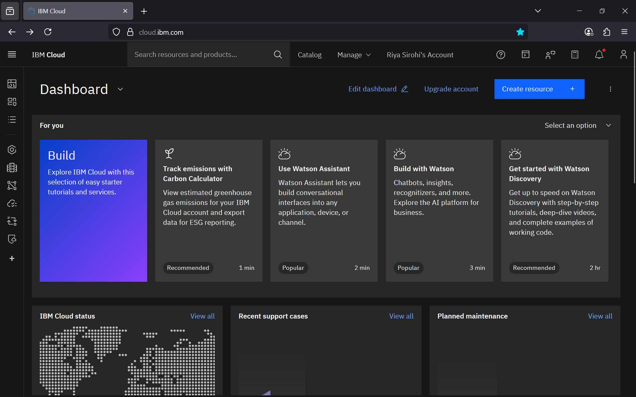

Step 1 – Firstly, login with your IBM Id and dashboard will appear. Search Watson.ai Studio.

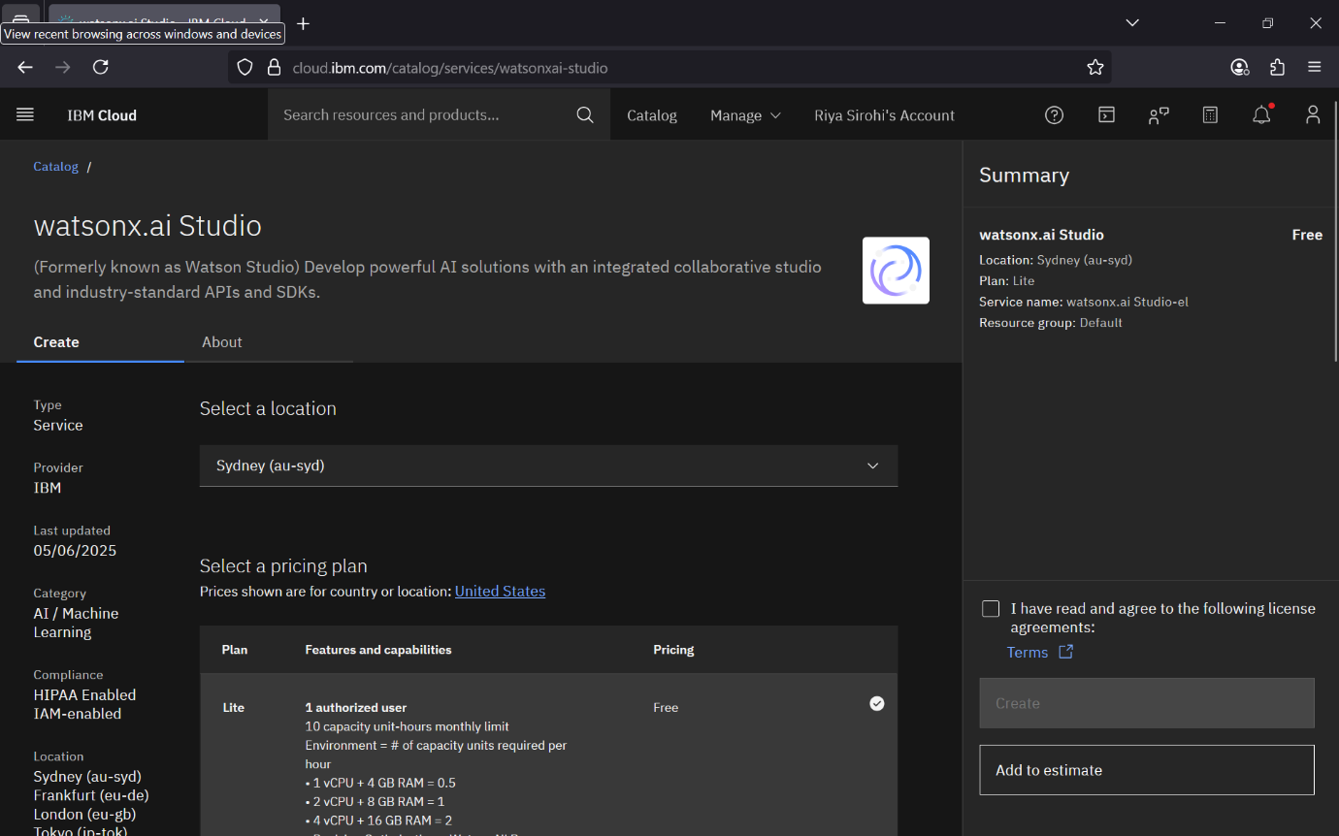Step 2 – After selecting Watson.ai Studio, this creates window will appear where you can select your location, plan and rename it and finally agreeing with the terms and create it.

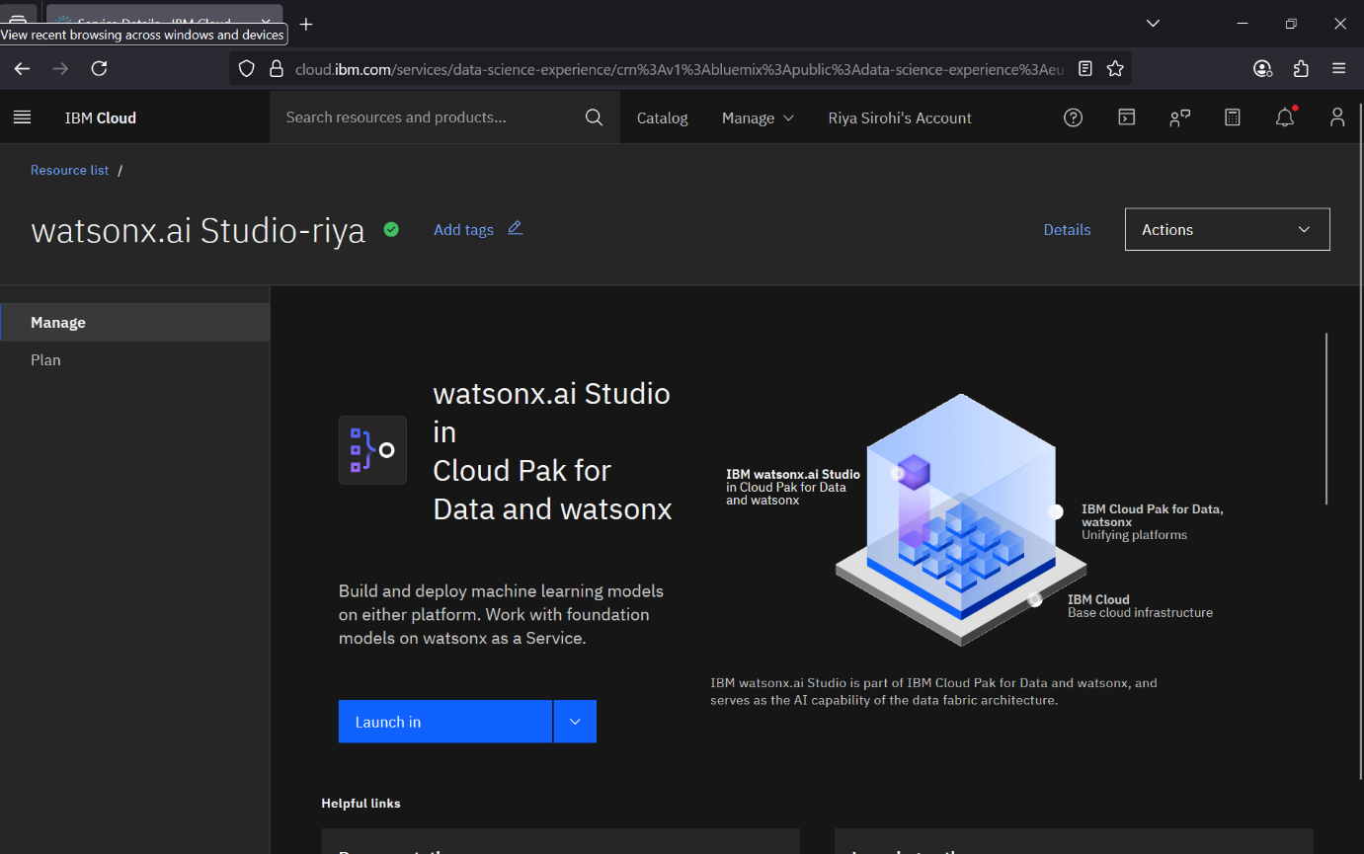

Step 3 – After creating this window will appear, in manage option you will launch it with either two plans Cloud Pak or Watson. We will choose Cloud Pak and launch it.

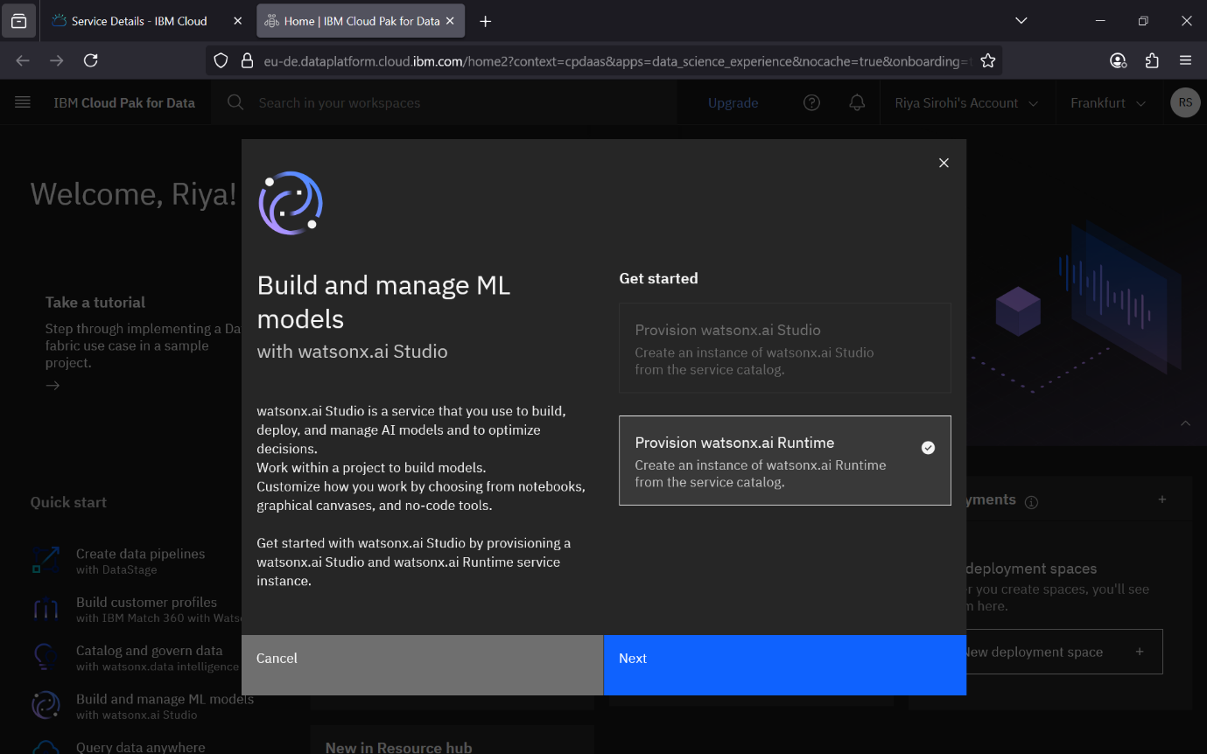

Step – 4 After this this pop up will appear just simply click next.

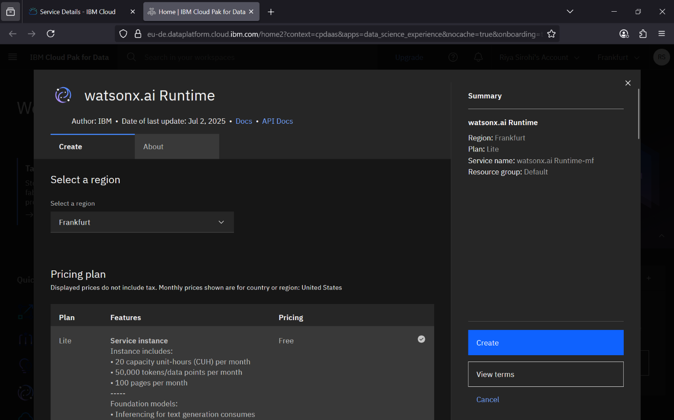

Step – 5 Again here select the region, plan and rename it and create it. In this step your watsonx.ai runtime resource will be created that helps in running the project.

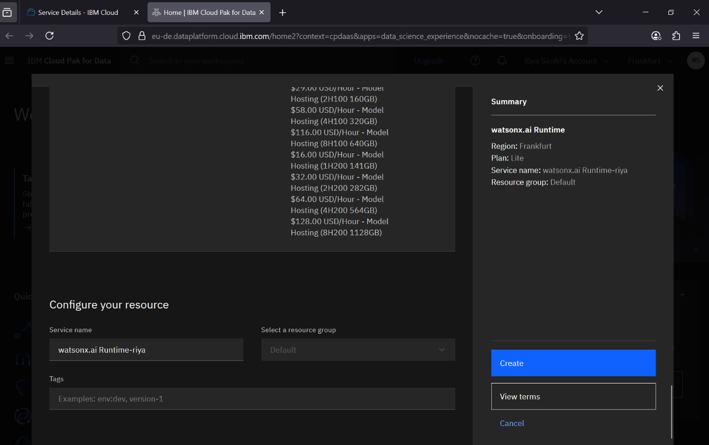

Step – 6 Here configure the resources as mentioned in above the step and create it.

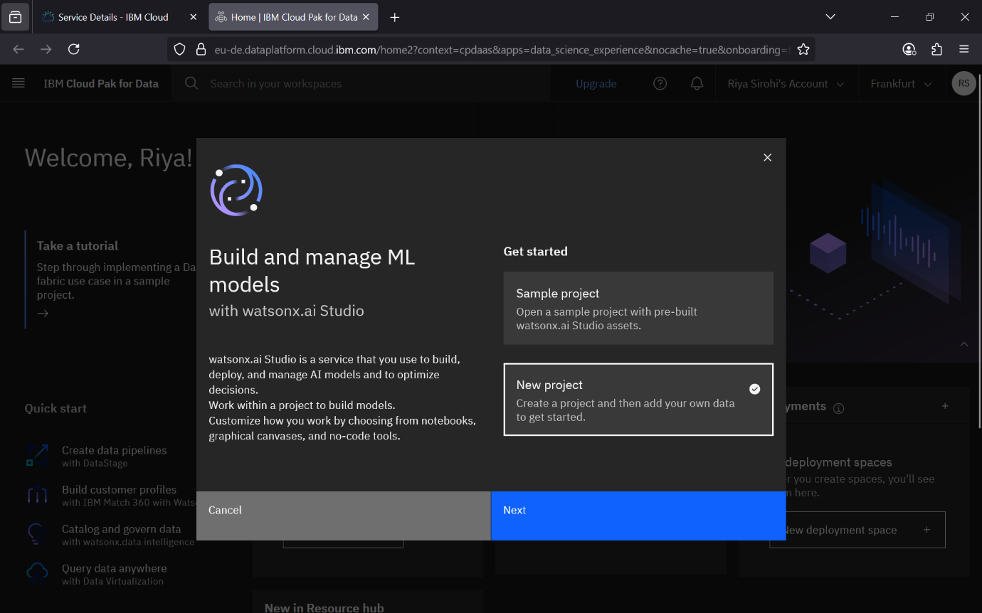

Step – 7 This pop-up window will appear and simply select new project and click next.

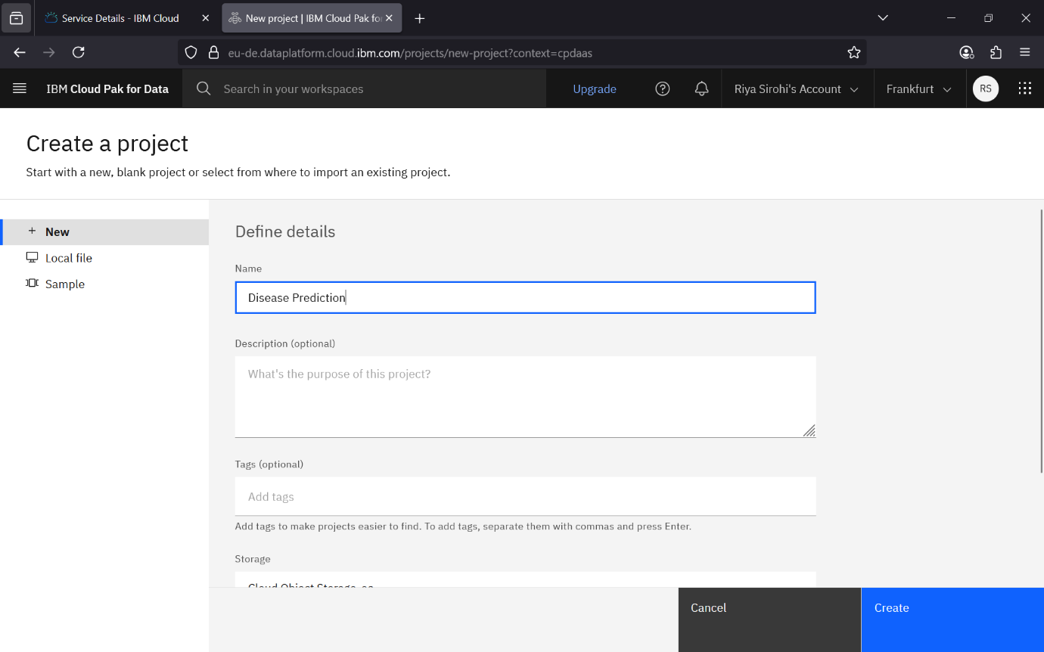

Step – 9 Here this create a project window will appear where you have to name the project and also if necessary add description and finally click create.

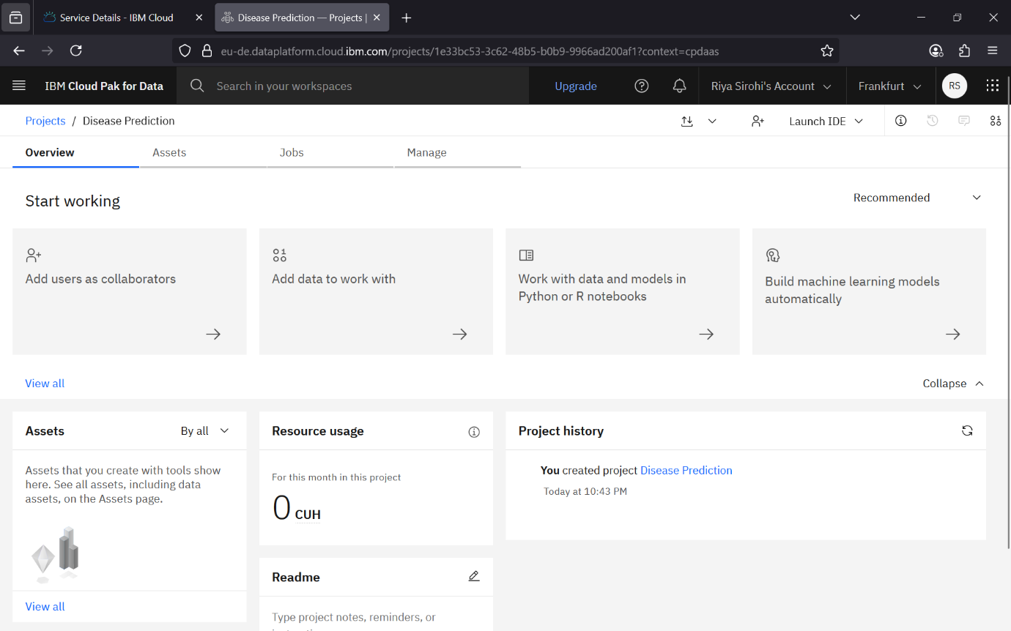

Step – 10 Now this is the window where we work. Here there are many options like:

* Add users as collaborators – you can add your friends or colleagues if working together on the project.
* Add data to work with – here you add your dataset you want to build on.
* Work with data and models in Python or R notebooks – here notebook will be available for code section to work with your data.
* Build machine learning models automatically – Here you can build model without coding and directly.
* Assets – show all the assets (Datasets, or the assets you create)
* Resource usage – show the amount of storage used. Etc.

So, at this step we will click on add data to work with to attach our dataset.

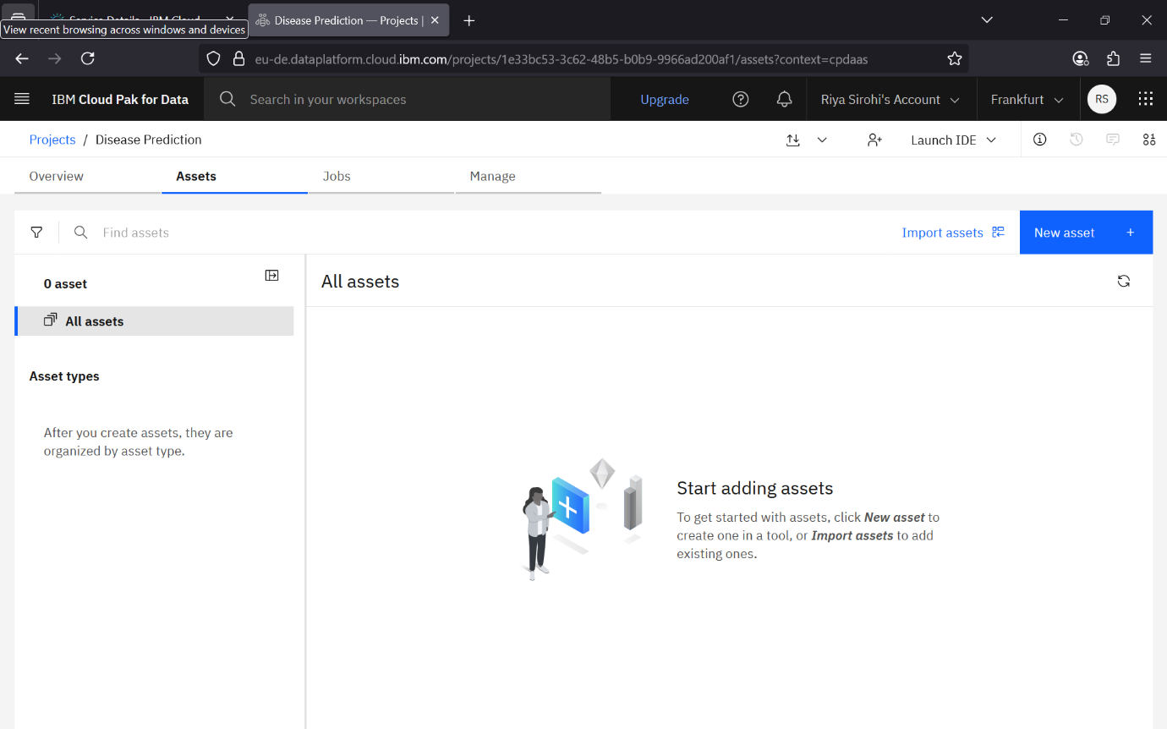

Step – 11 Here click on new asset or you can click on import assets as well to import your data.

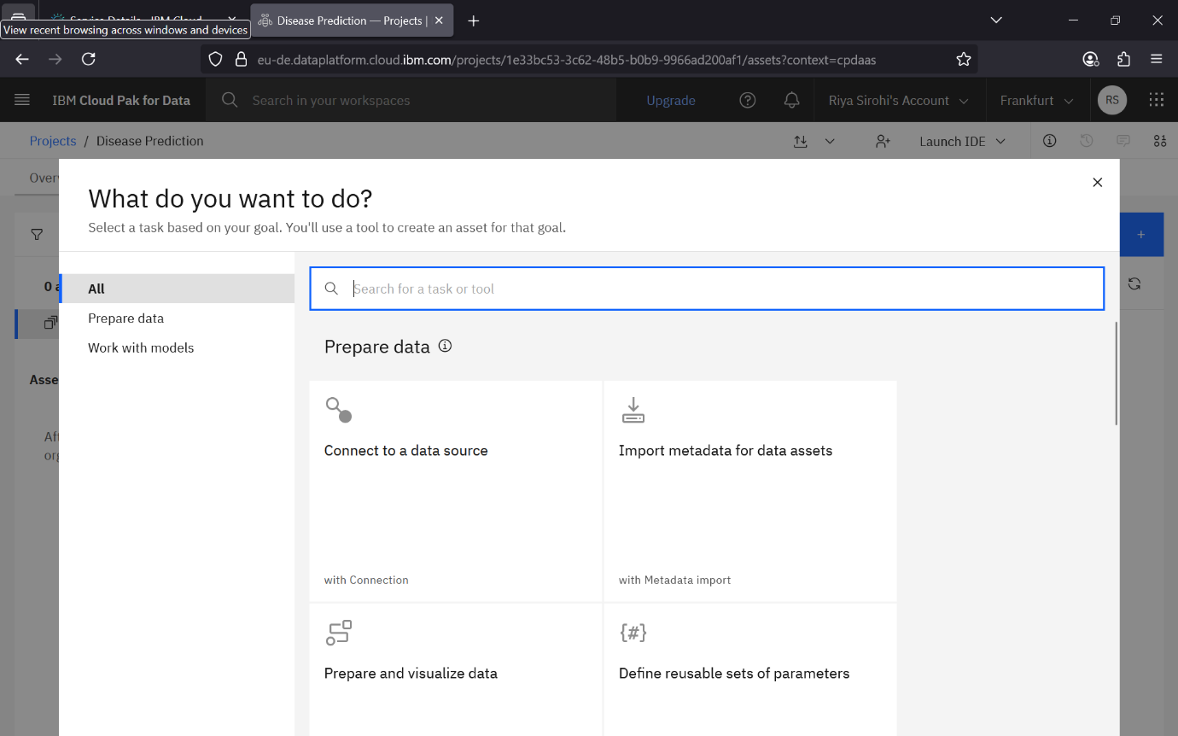

Step – 12 Here there are option like prepare and visualize data where you can prepare your data like by renaming column, changing datatype etc. if necessary. But we will scroll and click on Build Machine learning model automatically

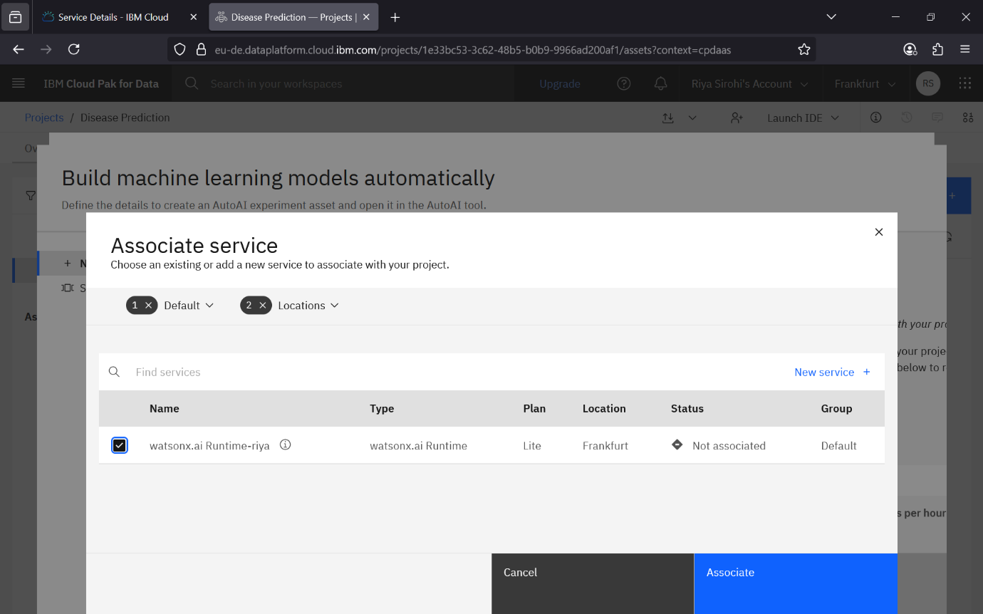

Step – 13 Here this associates service window appears where you have to select to your runtime resource you created and then click on associate so that it gets associated with your project.

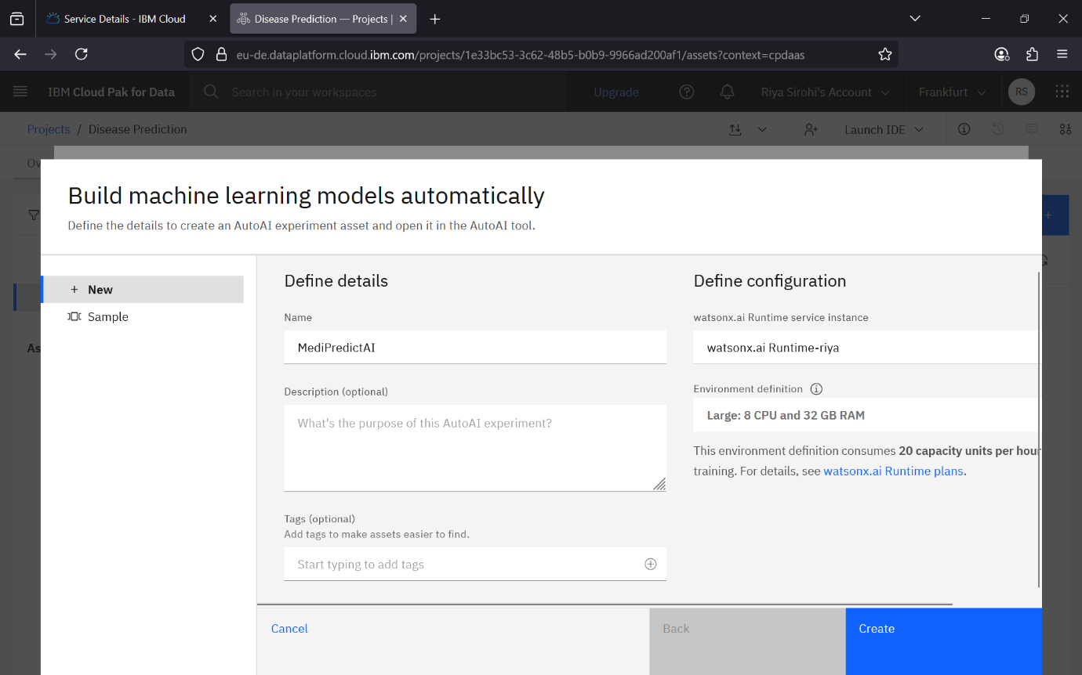

Step – 14 Now here you can give name to your project and simply click on create. The other details like description and tags are optional.

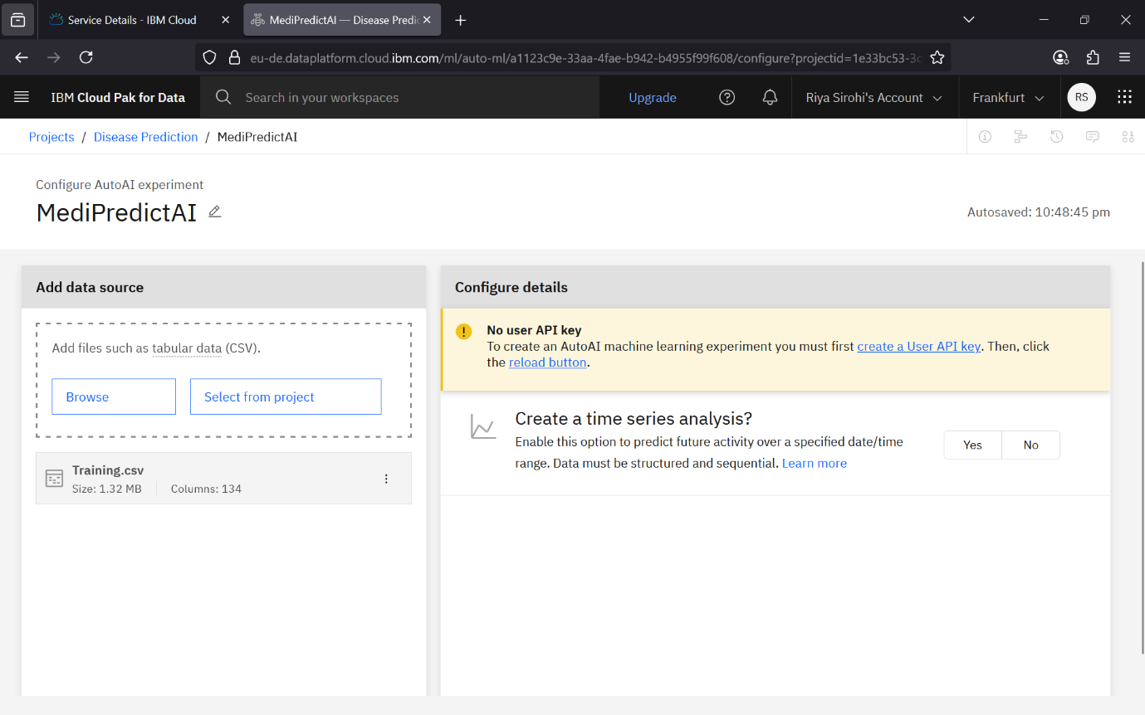

Step – 15 Here it will ask you to browse the dataset if you haven’t done already and then will ask you create a User API Key.

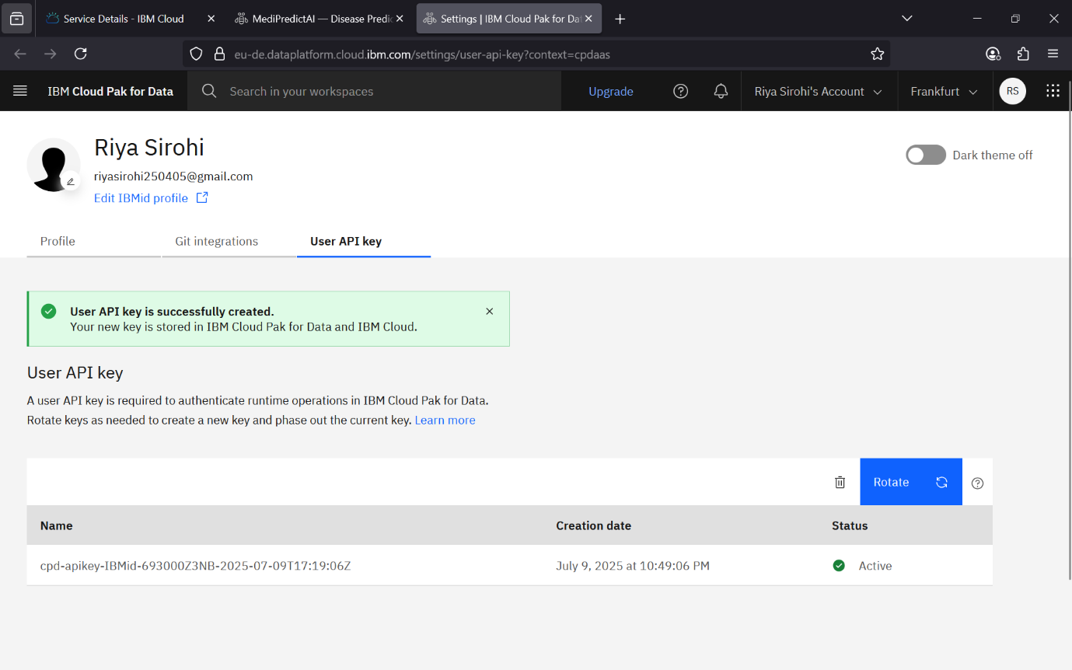

Step – 16 Here a new window tab will open and an API Key will be generated.

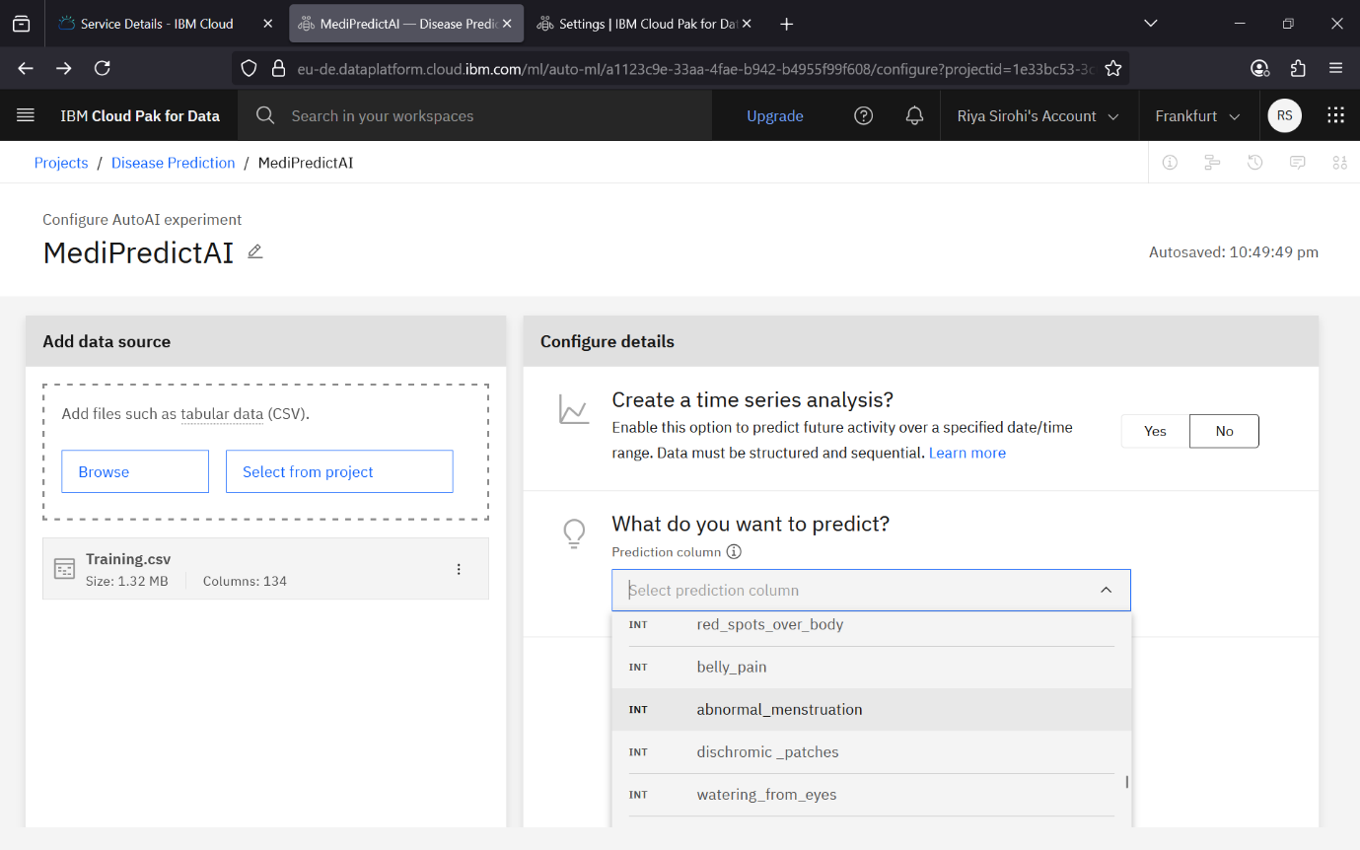

Step – 17 Now you have to select in the drop-down menu what you need to predict. So here I will select the Survival Option as my dataset is about Titanic Survival.

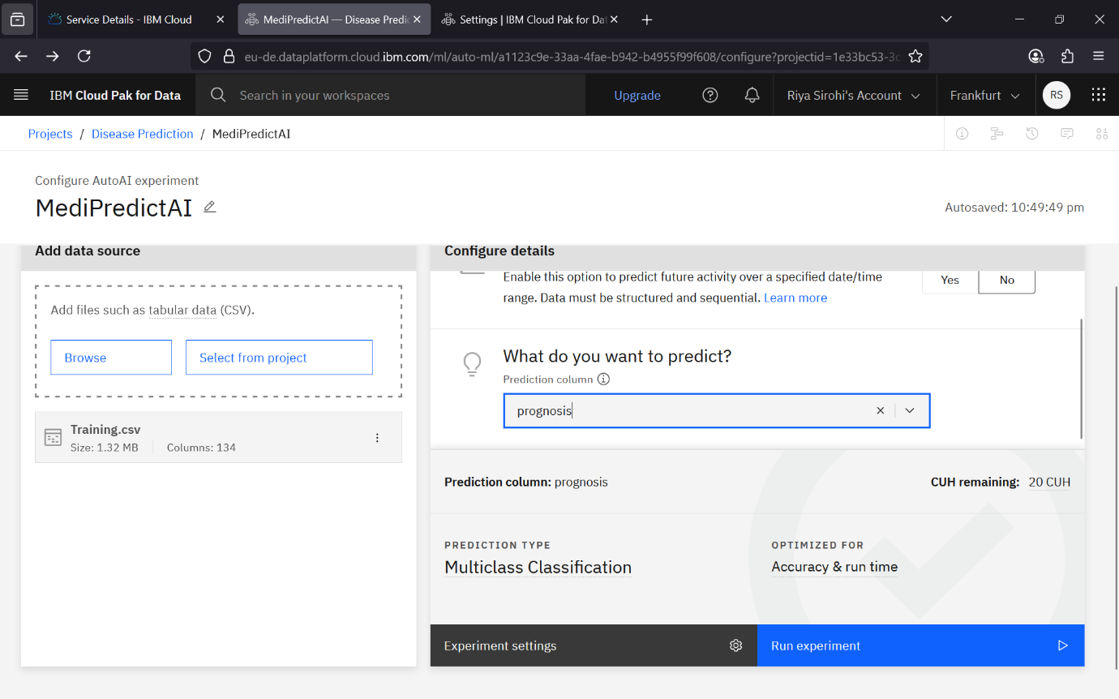

Step – 18 Now after this it will select the prediction type itself and will be optimized for accuracy and runtime. As you can see here, for my project is selected Binary Classification.

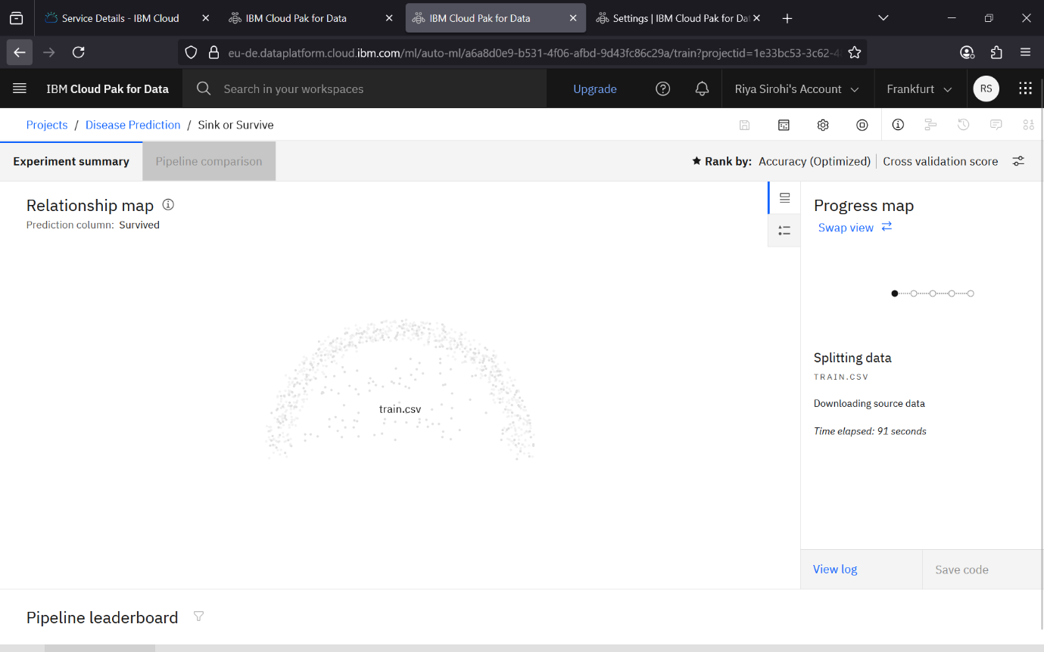

Step – 19 Now here finally the training of your dataset will begin.

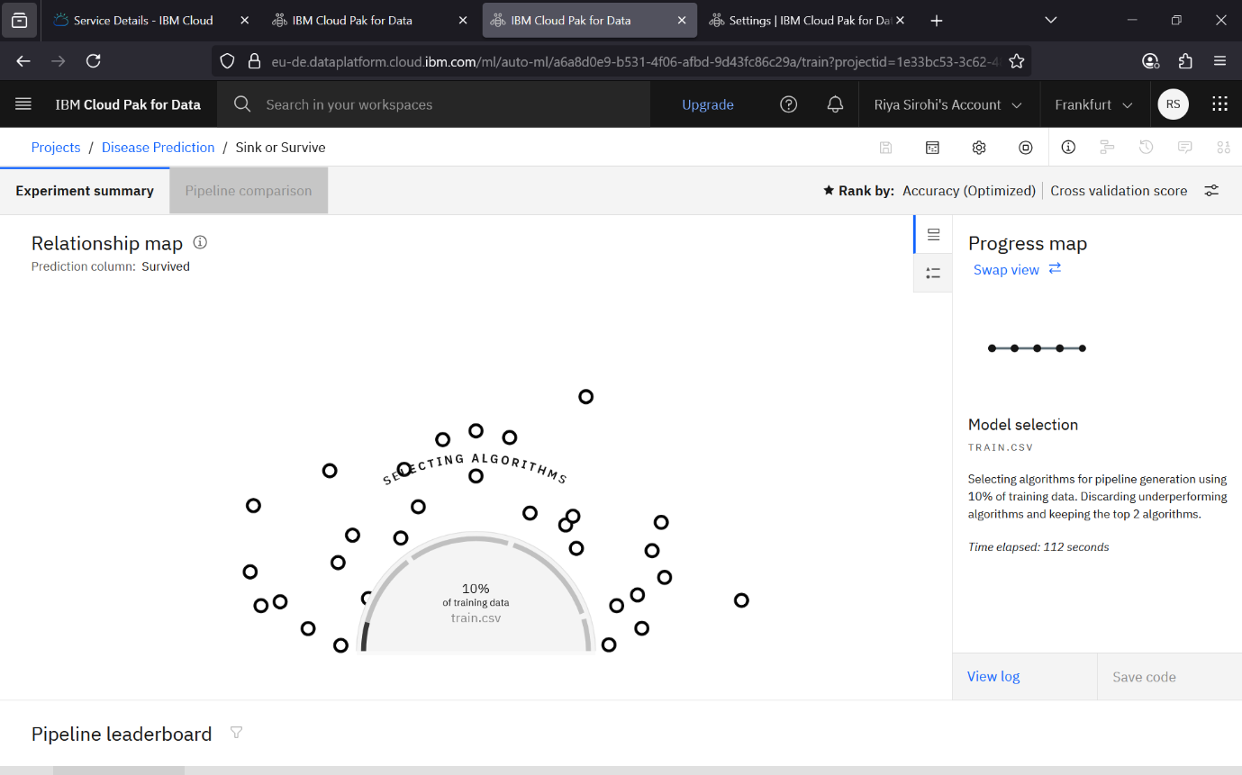

Step – 20 You can see in this step that it starts selecting the algorithm for prediction.

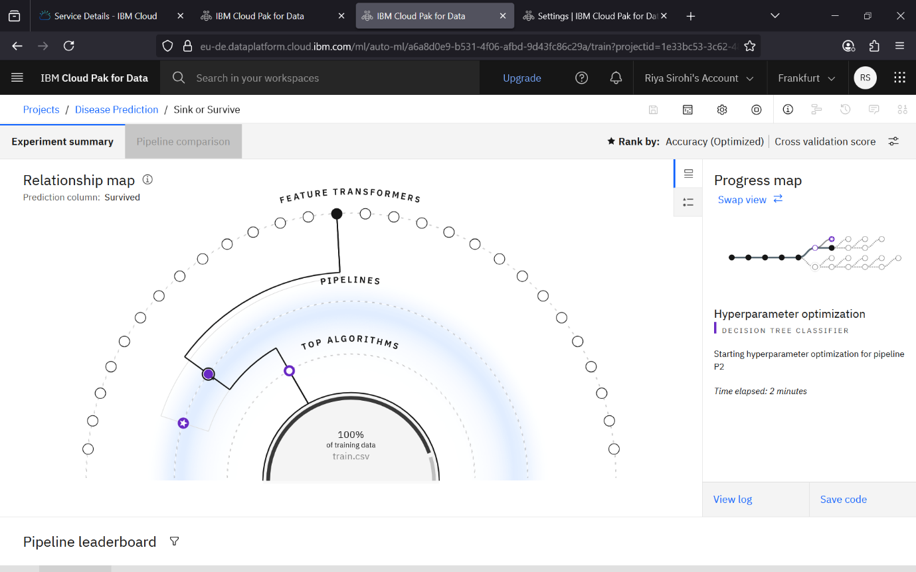

Step – 21 Here pipelines will be created and feature selection will begin.

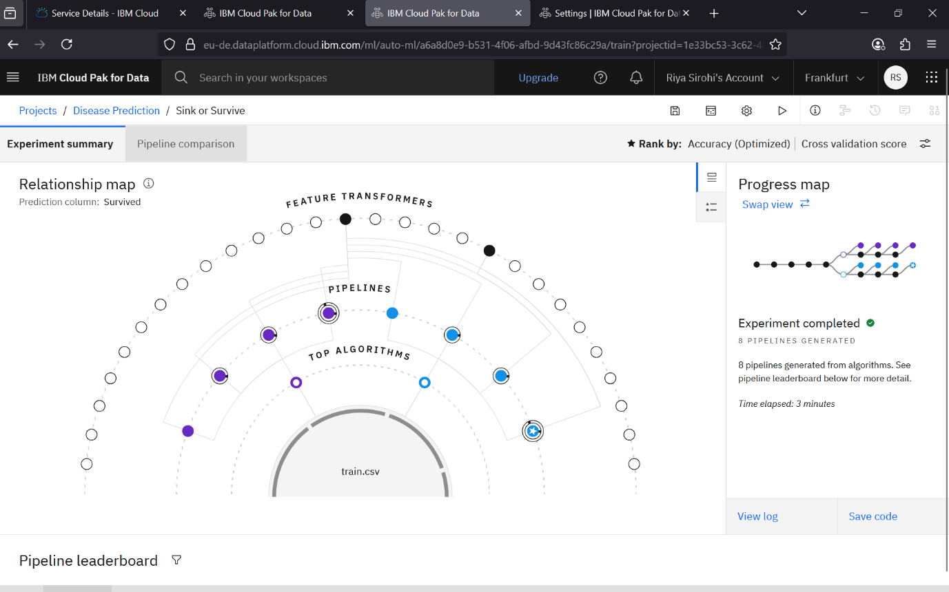

Step – 22 The experiment after few times will be completed and you can see the best pipeline. Here in my project, it used 2 algorithms – XGB Classifier and Decision Tree Classifier.

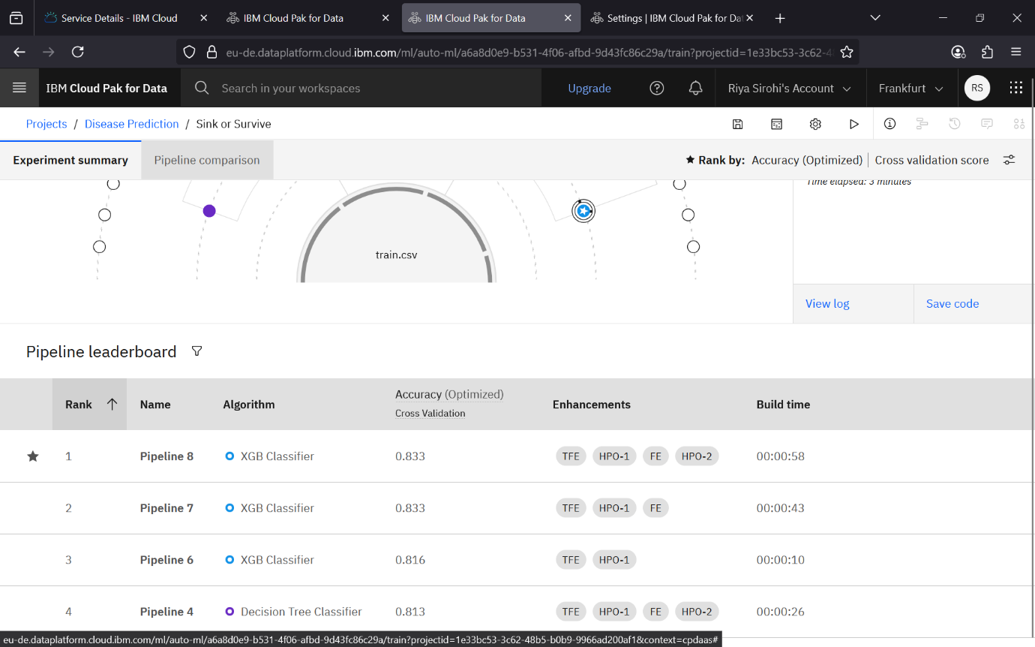

Step – 23 Here you can see the best rank is given to pipeline 8 having 83.3% accuracy so we will save that model.

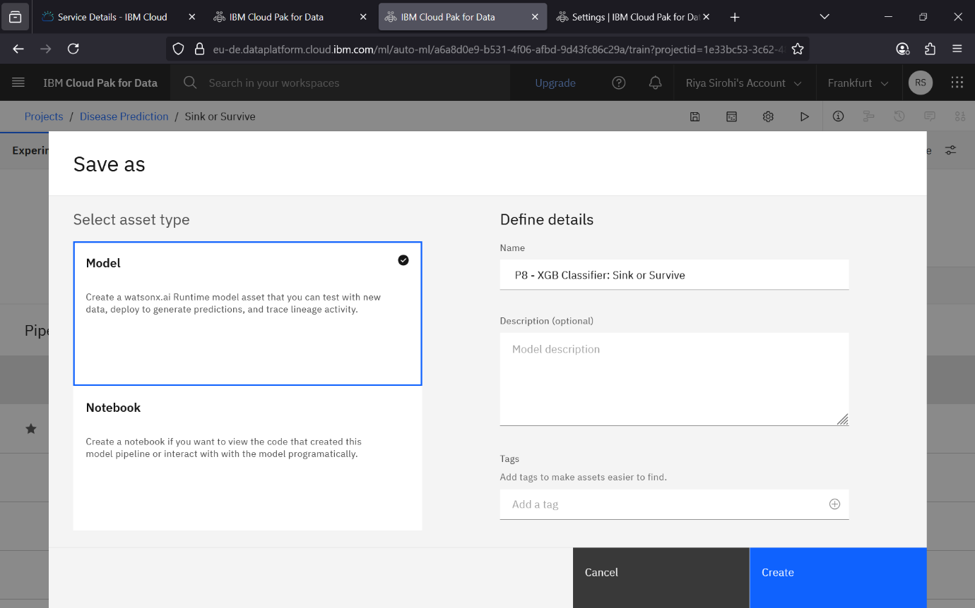

Step – 24 Here you will save the pipeline as model and simply click on create.

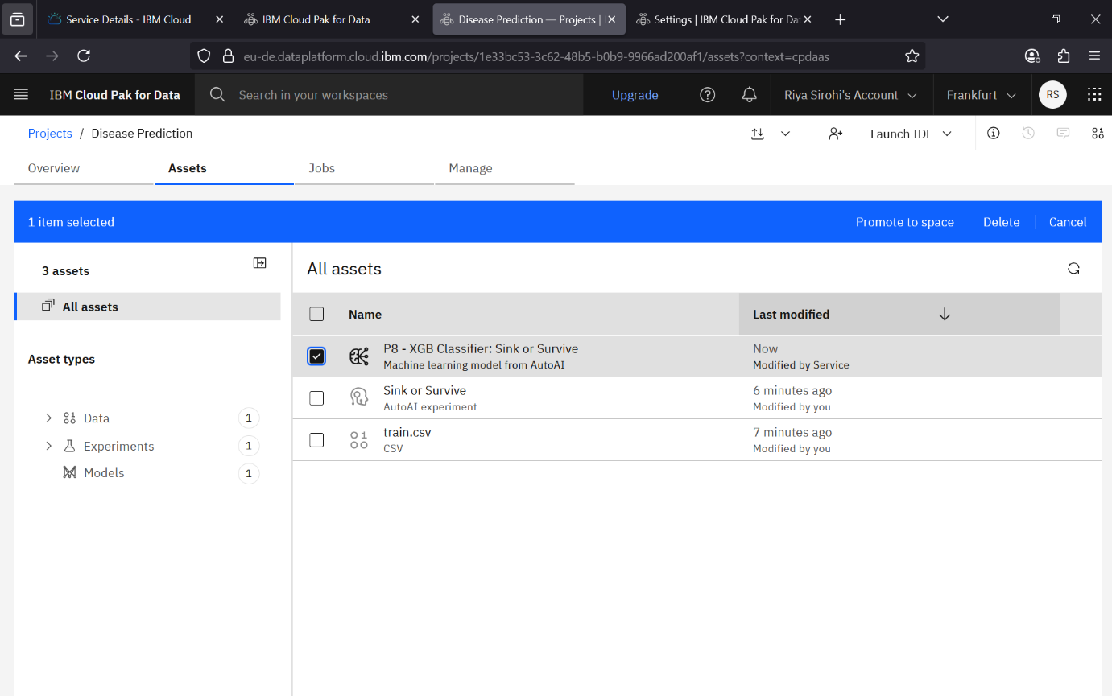

Step – 25 Here now you can check a new asset will be created that is your model you saved. You can simply select it.

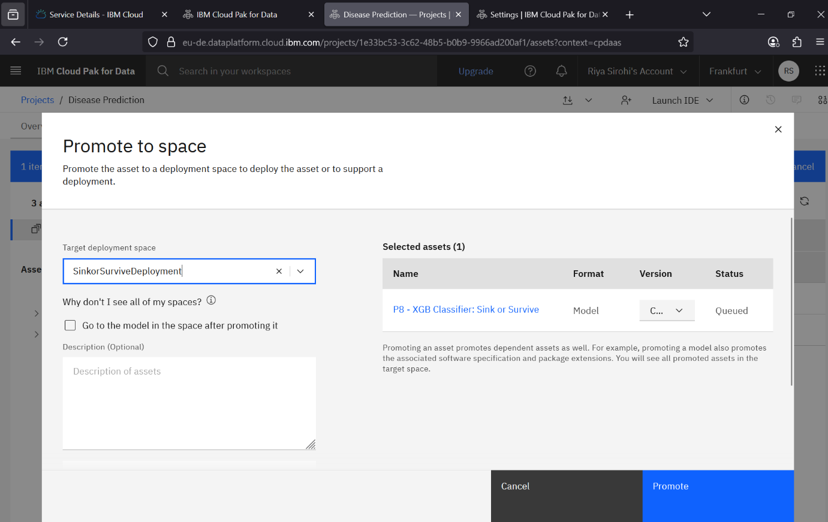

Step – 26 this promote to space window will appear you can name your target deployment space and just simply click on promote.

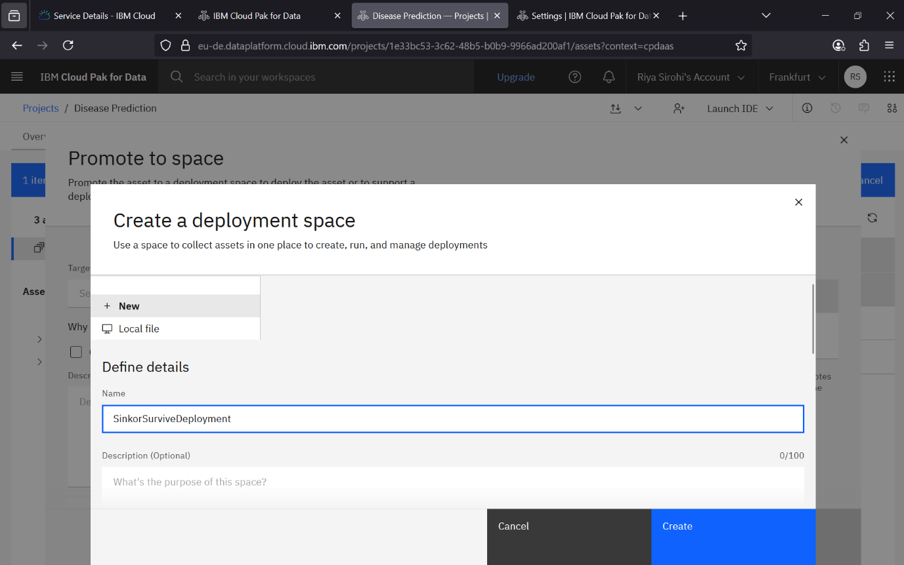

Step – 27 Here we will create a deployment space for our model and you could name it. And then click on create option.

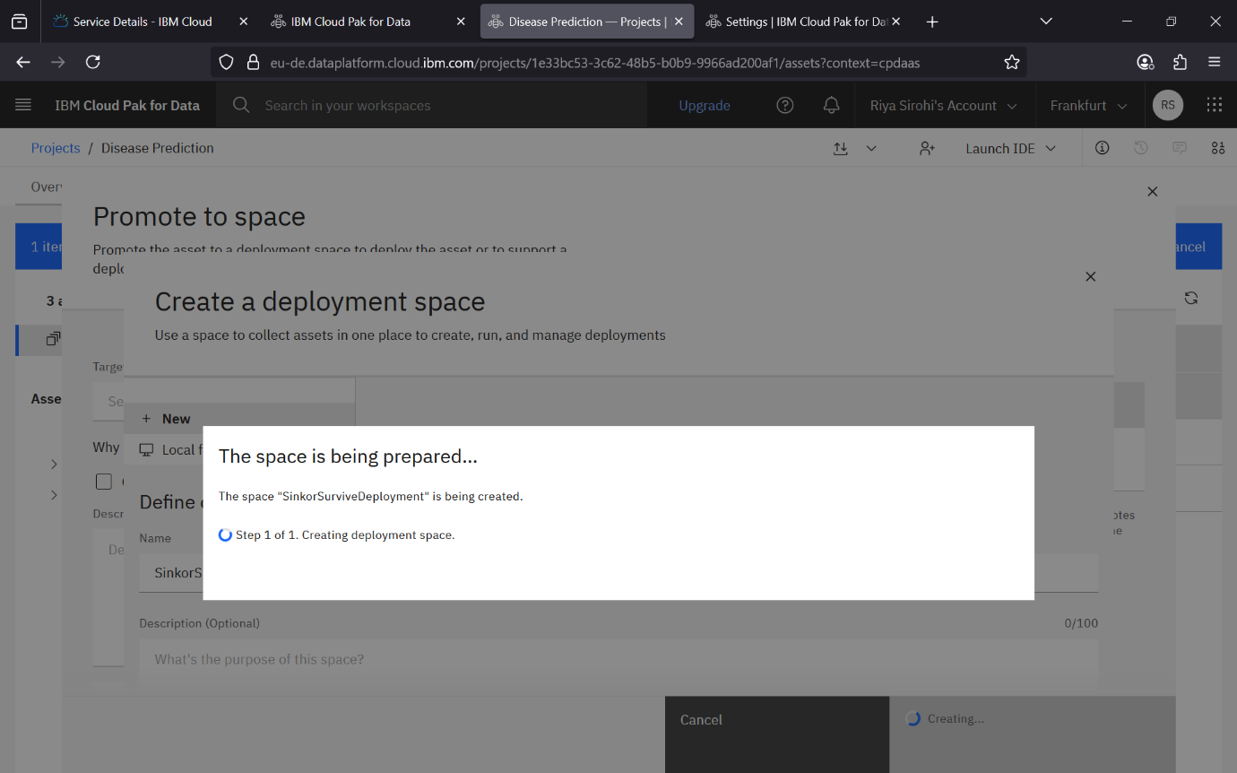

Step – 28 Now this loading screen will appear which might take some time as it is allotting space for deployment of your project.

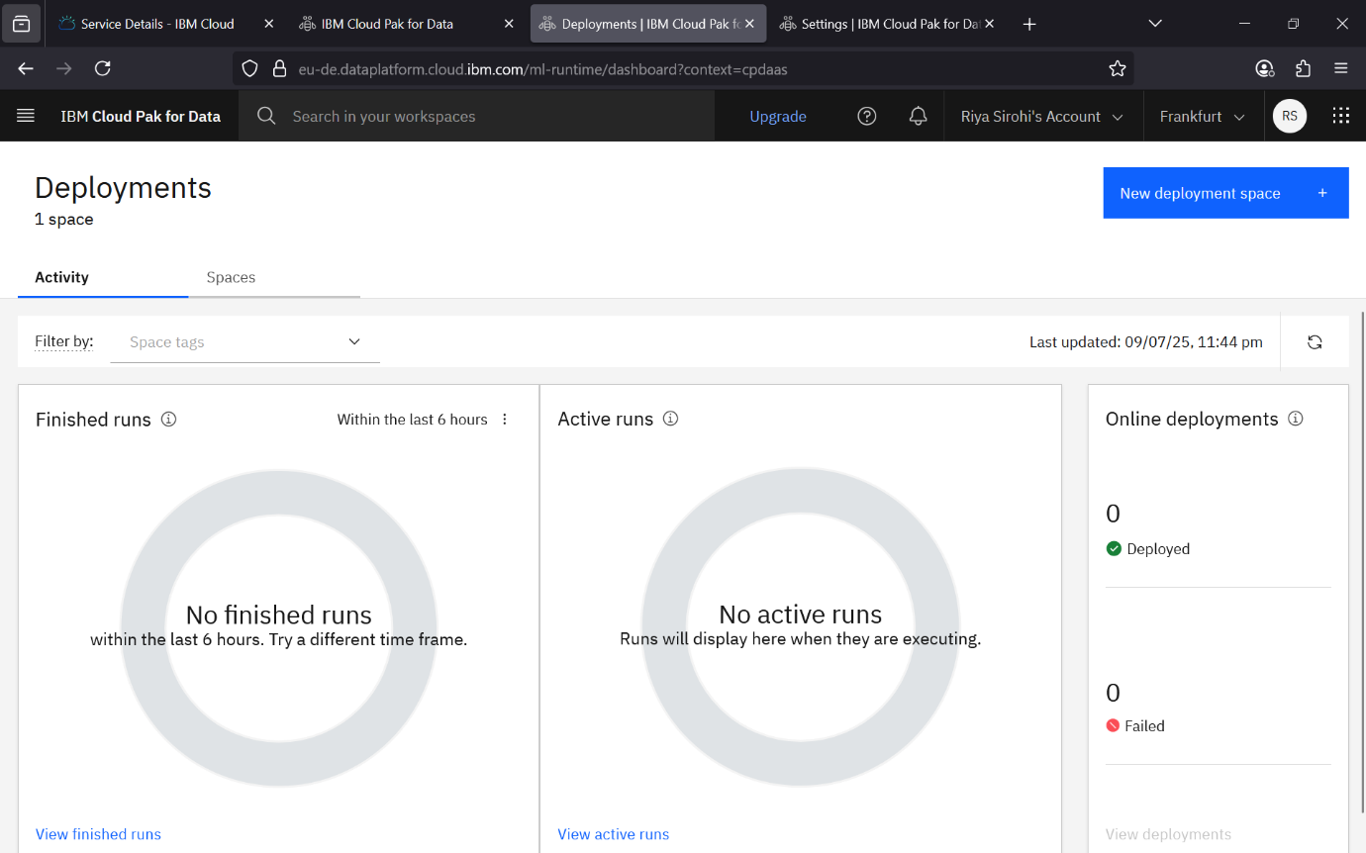

Step – 29 Now here you can see the deployment tab showing finished and active runs.

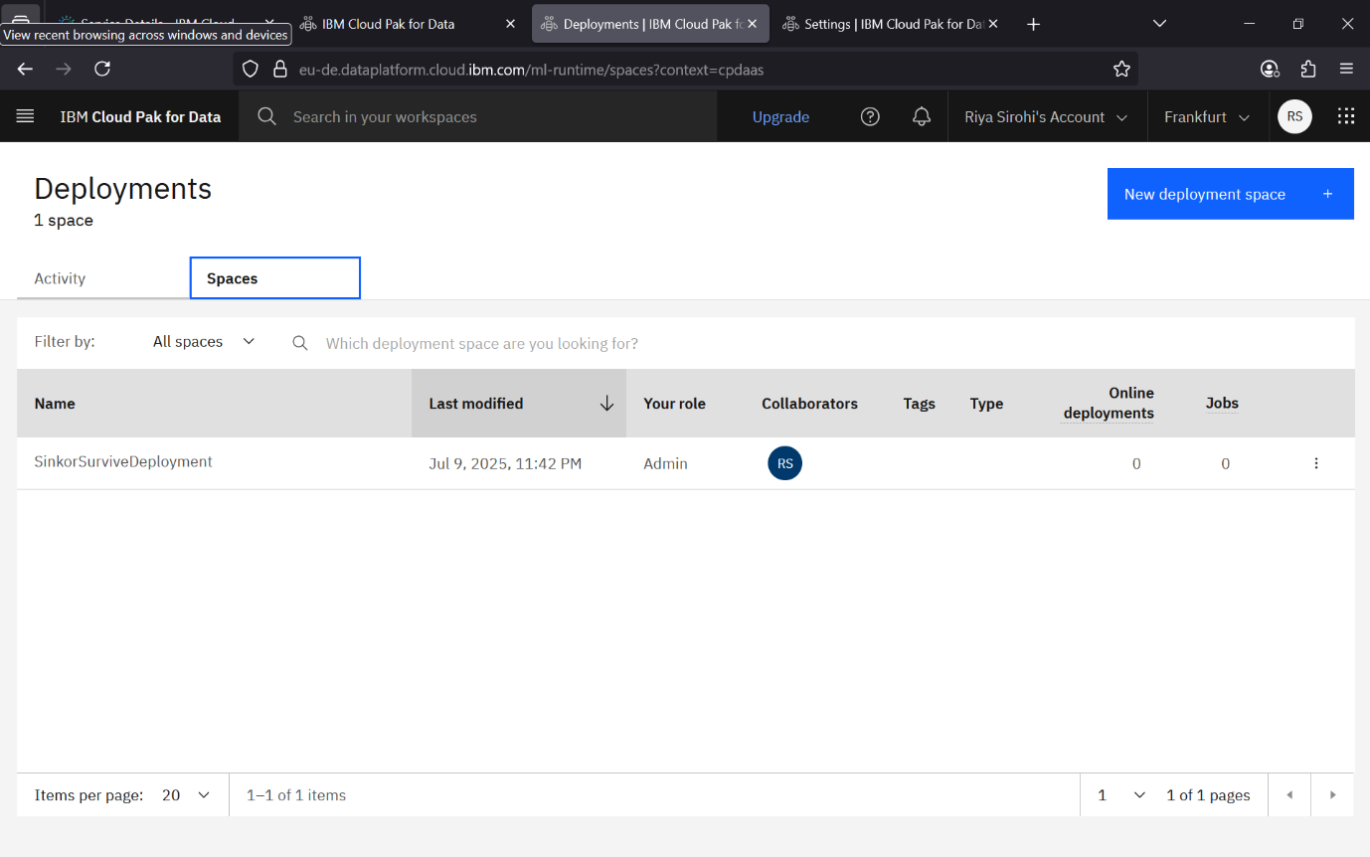

Step – 30 Here in spaces options you can see the space is allotted to your project. Now click on simply the name of your deployment as here it is – SinkorSurviveDeployment.

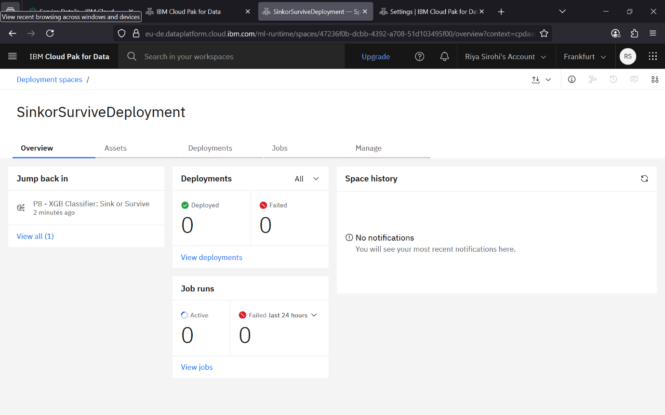

Step – 31 This window will appear and you could see in the overview that deployed and failed options for deployments and job runs.

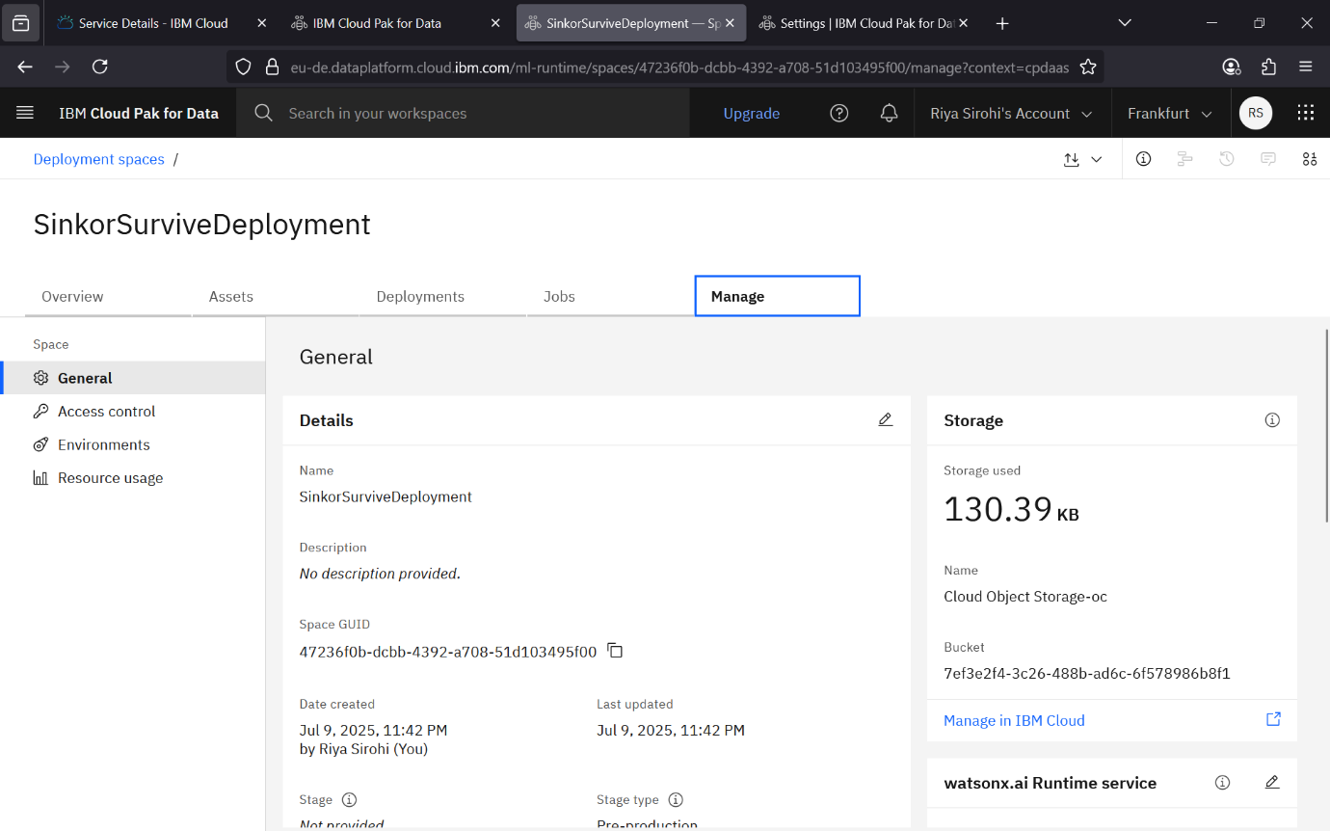

Step – 32 And now go to the manage option, you could see the space allotted. Here it is 130.39 KB.

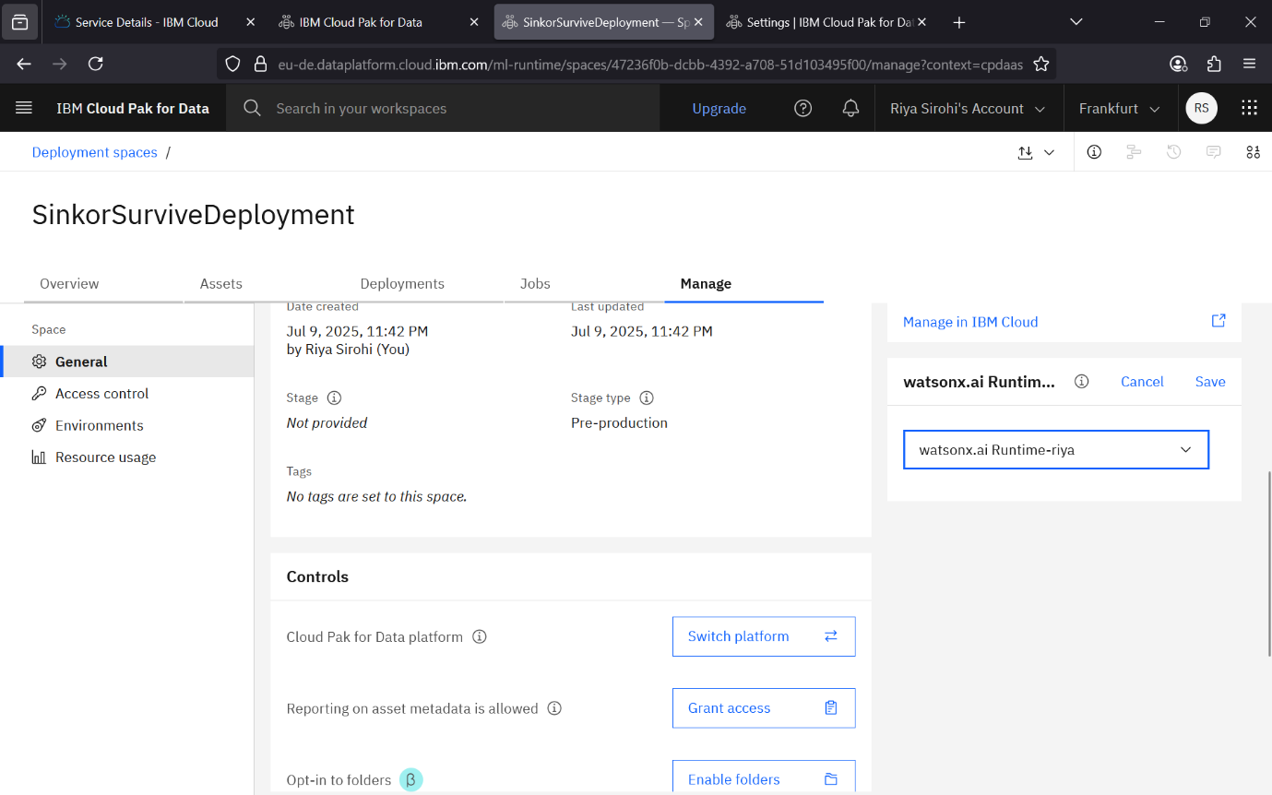

Step – 33 Here the on same manage window scroll it and select the Watson.ai runtime resource we created in initial steps.

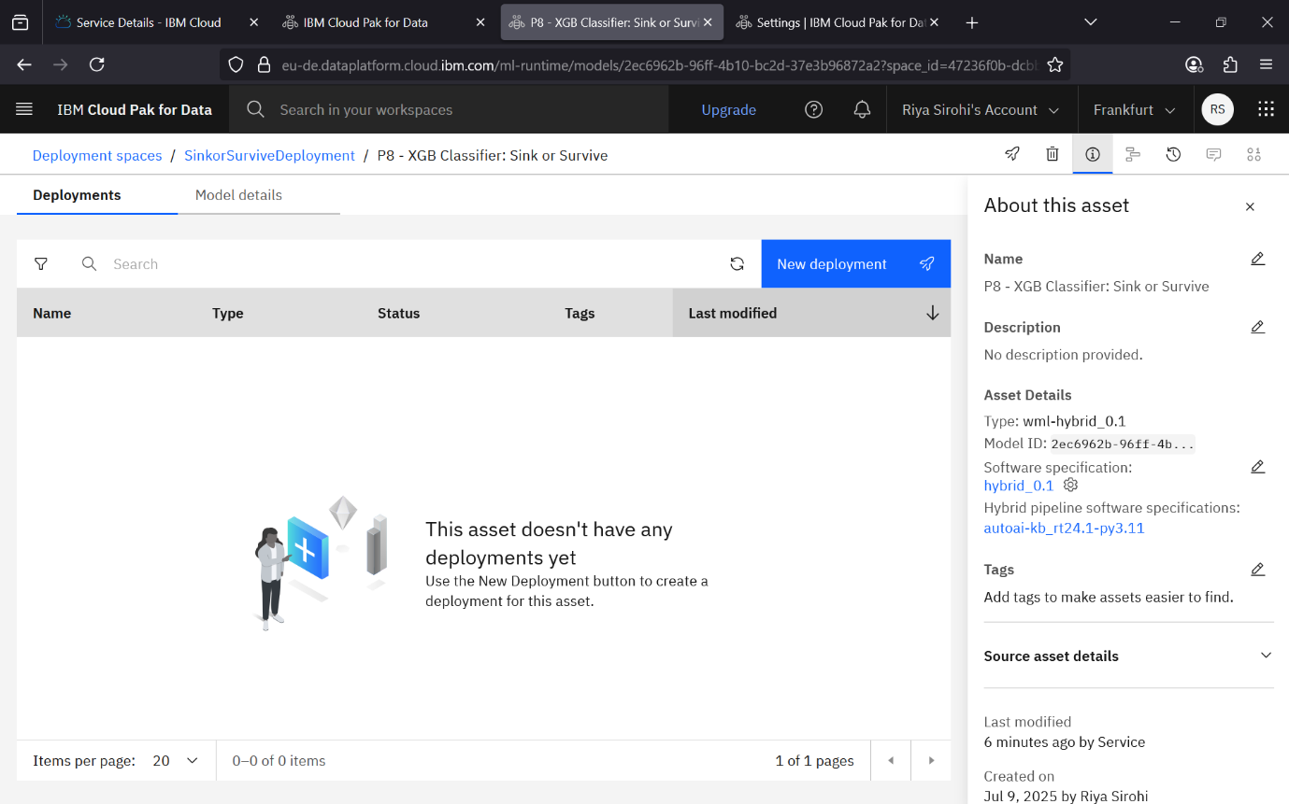

Step – 34 After all, this step will appear and here as you no deployment is done yet, so simply click on new deployment.

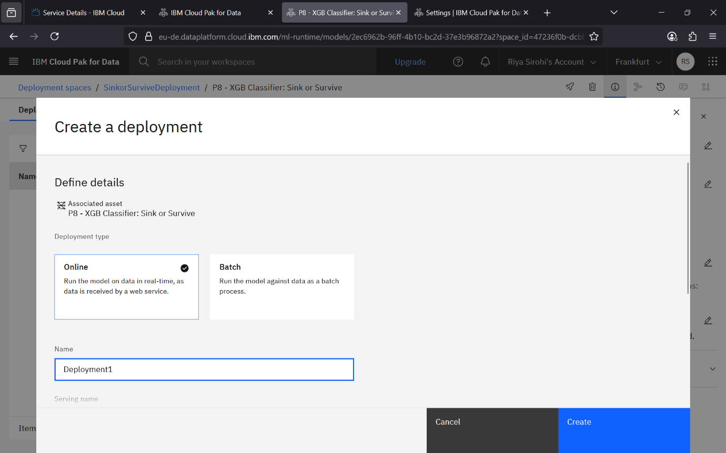

Step – 35 This create deployment window box will appear where you can select the deployment type that is Online and name your deployment. And click on create.

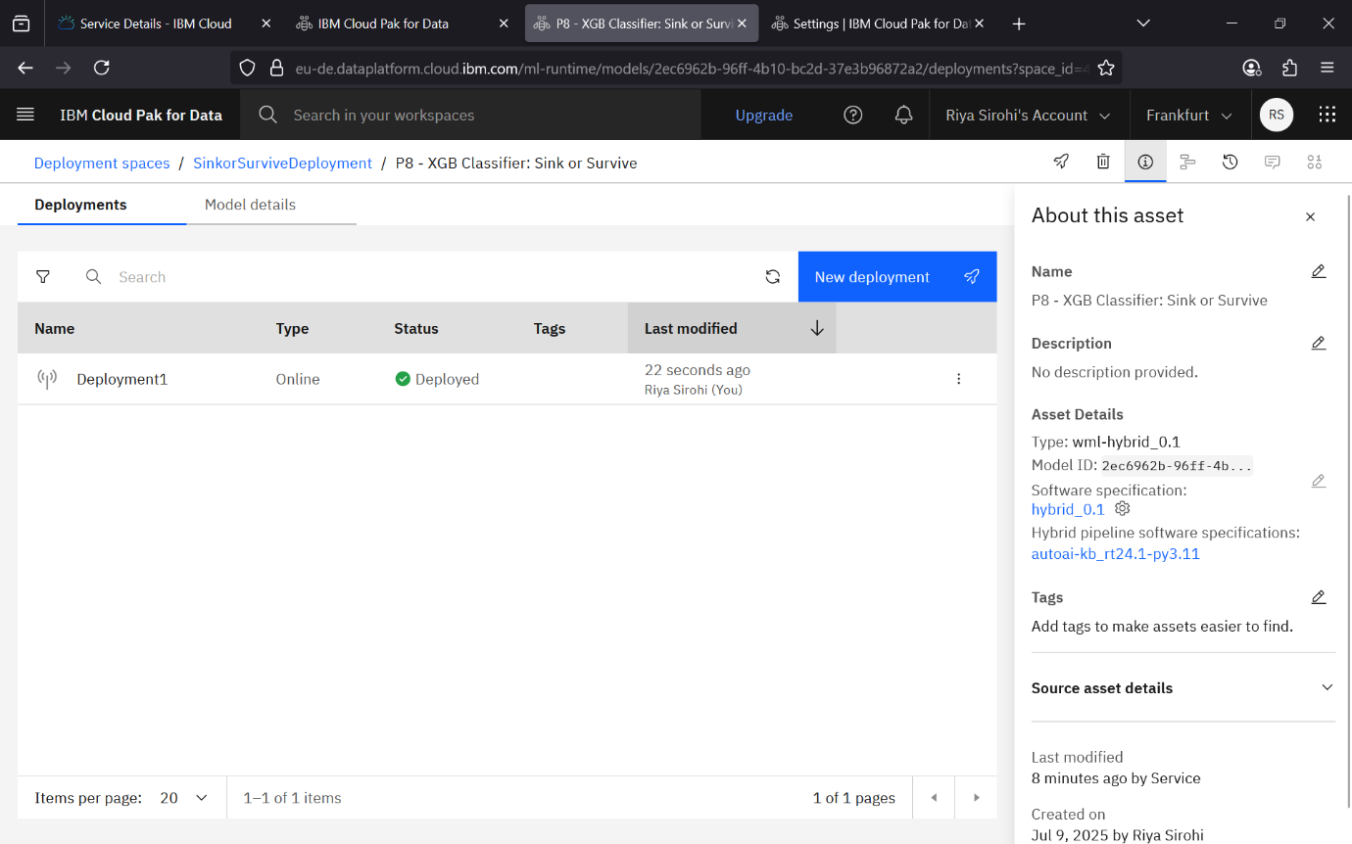

Step – 36 Now the deployment is created and you can check the status saying deployed. Then click on the name of your deployment – Deployment1 (here).

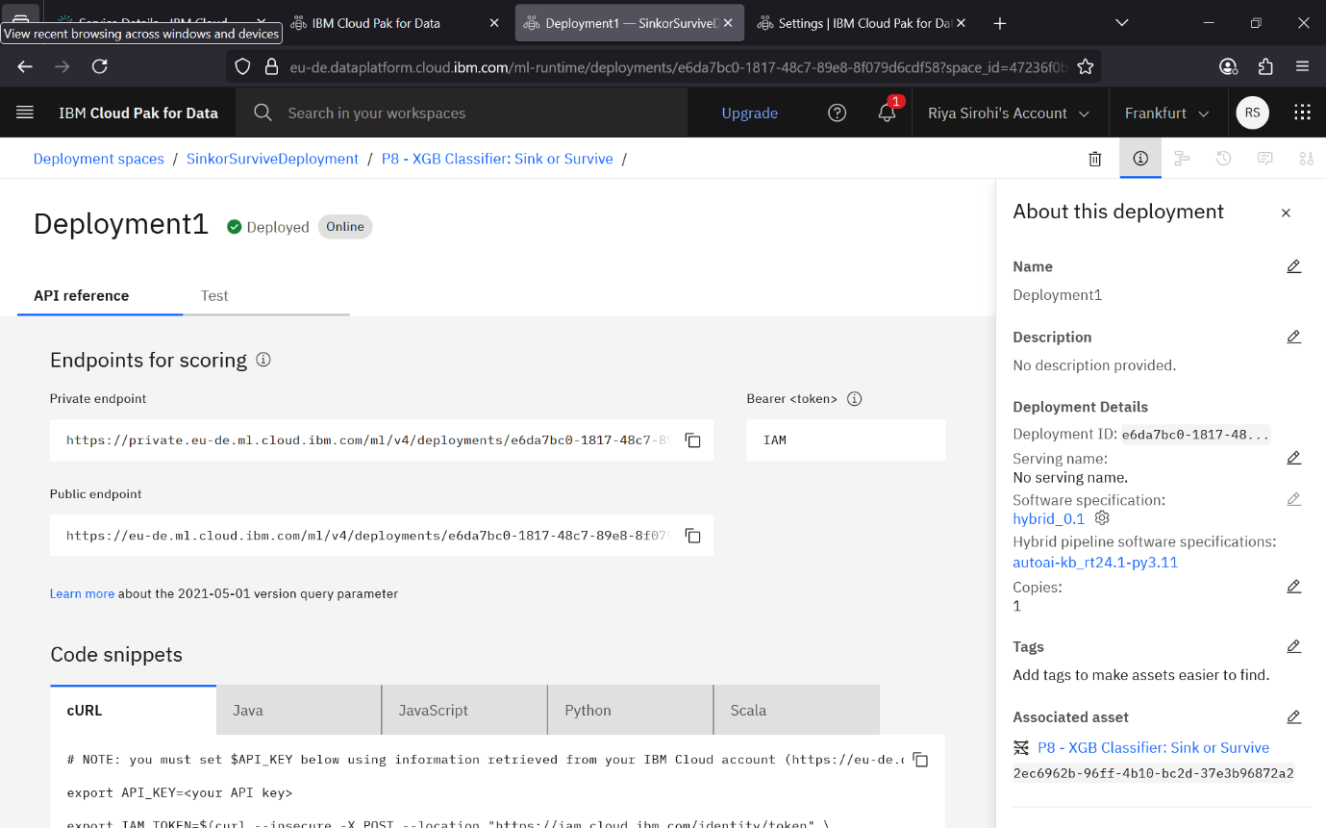

Step – 37 Here this window will appear, where your code snippets, endpoints for scoring is visible in the API Reference. So, scroll and select the code snipped in the language you prefer – here I will select in python.

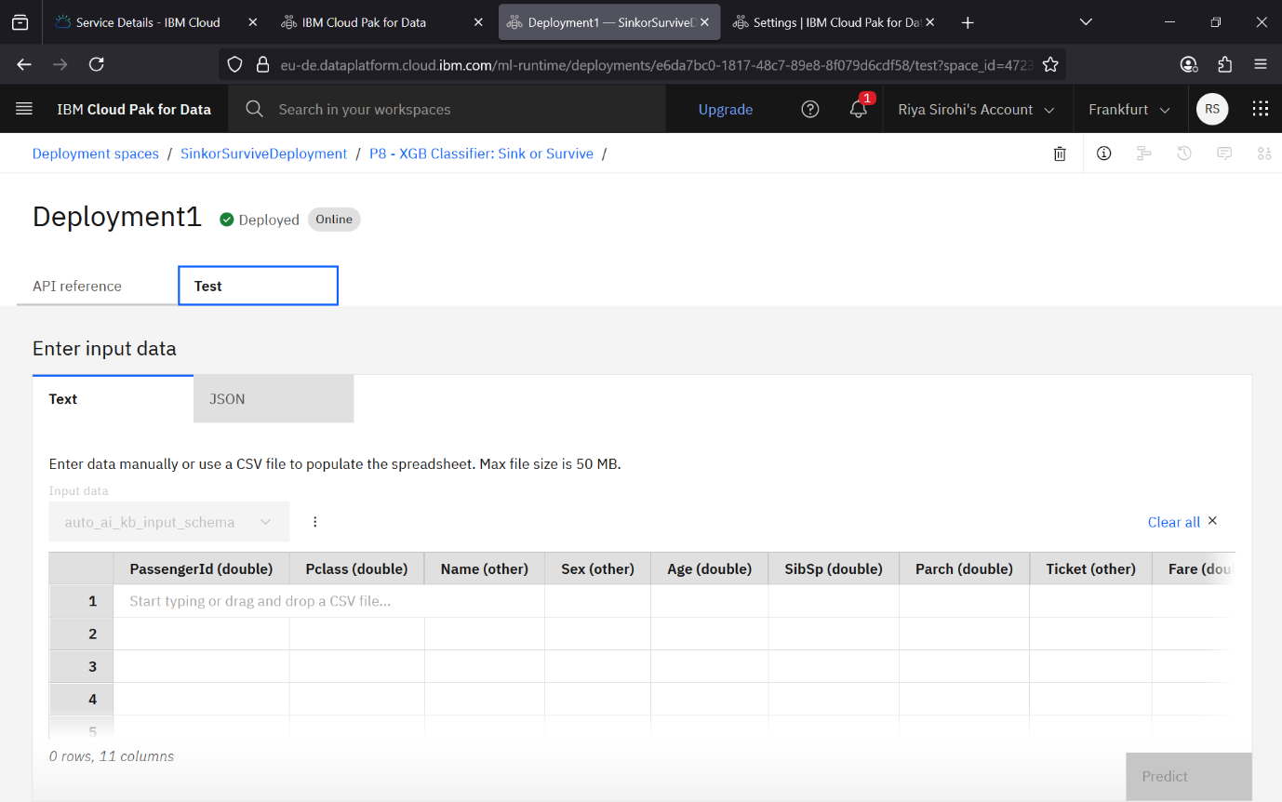

Step – 38 Here go to test tab and select the testing csv file so that it tests your model on it.

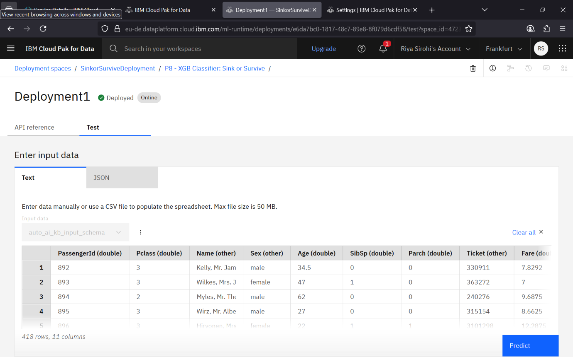

Step – 39 Here you can see the csv file is selected and it shows the preview for it.

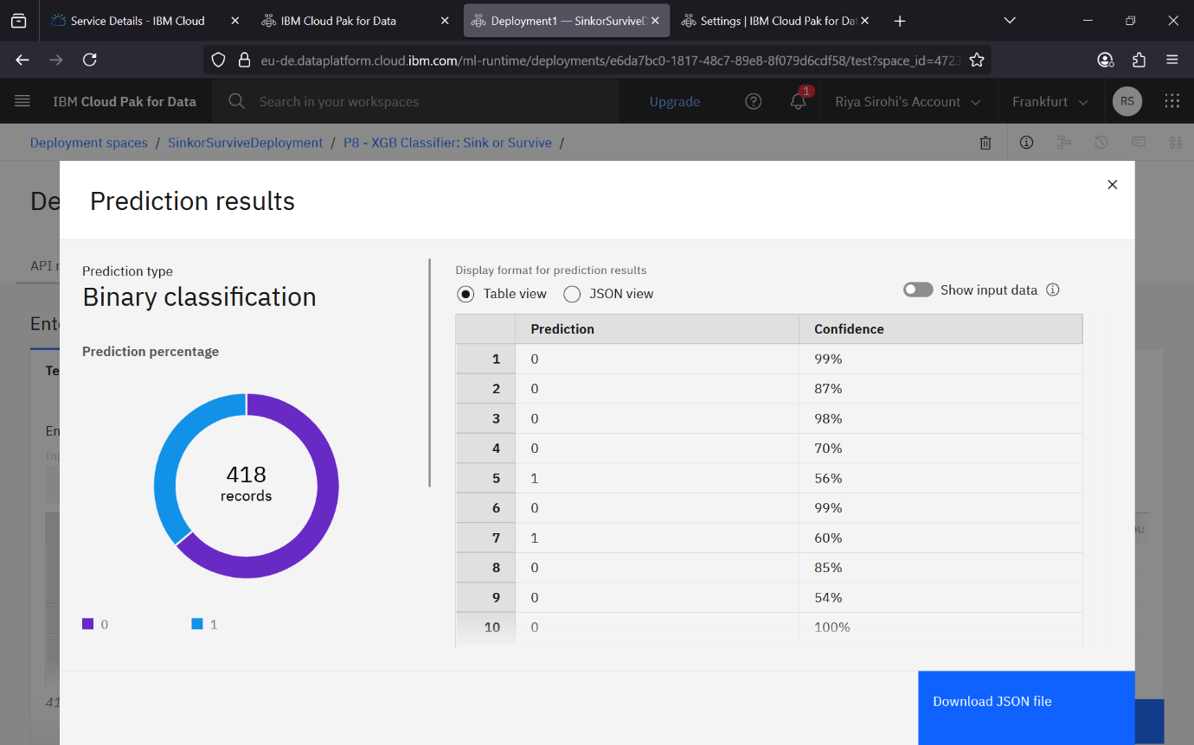

Step – 40 Now finally the prediction is done and you could see the output here. It shows prediction percentage in left and on right shows the table view for prediction and confidence in prediction.

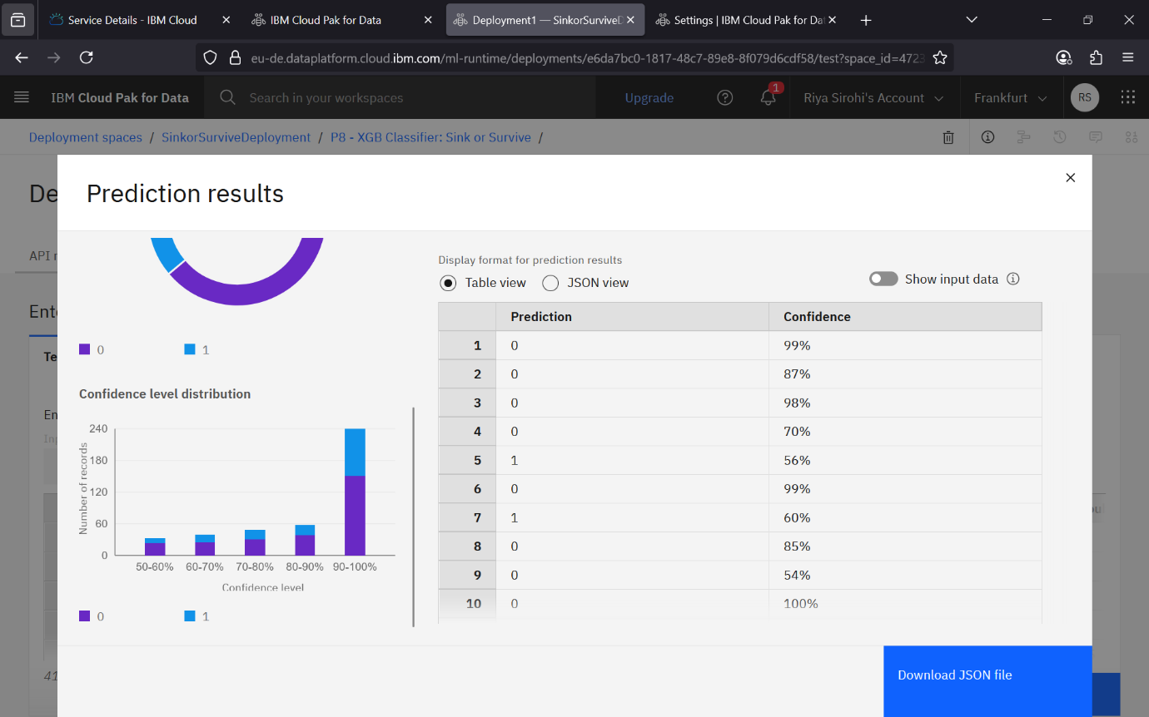

Step – 41 If you scroll you could see a bar chart as well showing your confidence level distribution. Now simply close the tab and create a new google colab file where you can attach the snippet you copied.

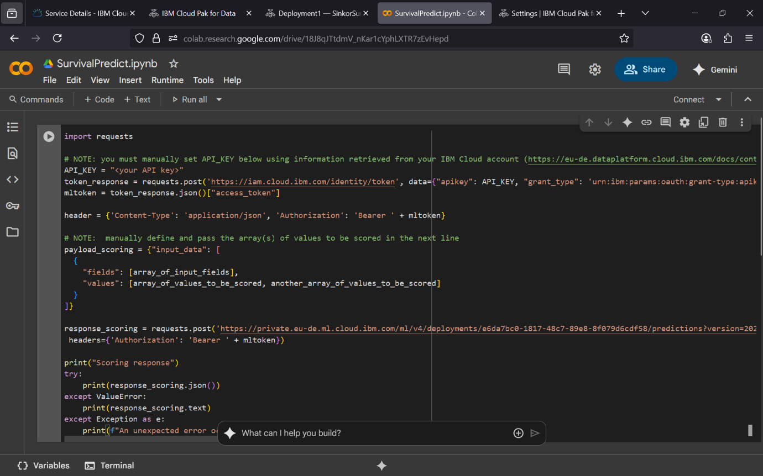

Step – 42 Here finally you can attach your code here and then make some changes. At first we need to copy the public endpoint link from Step-37 and simply attach in the response_scoring attribute.

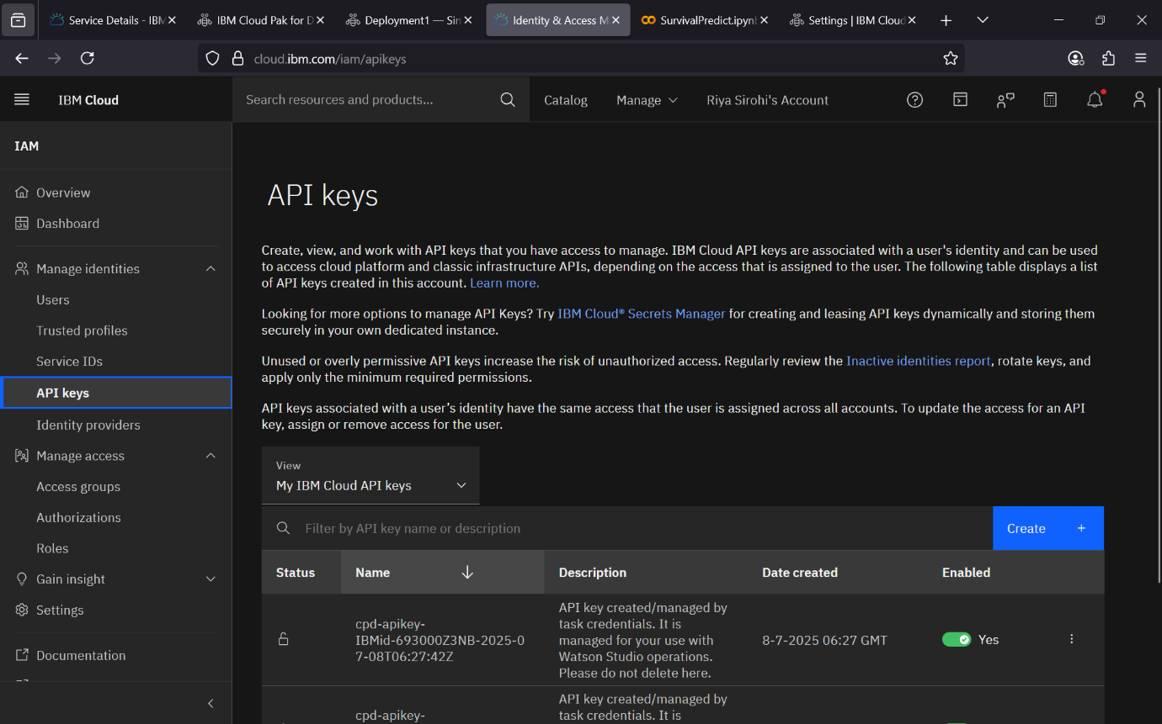

Step – 43 Now when you go back to previous tab, you will see option of API keys simply create one.

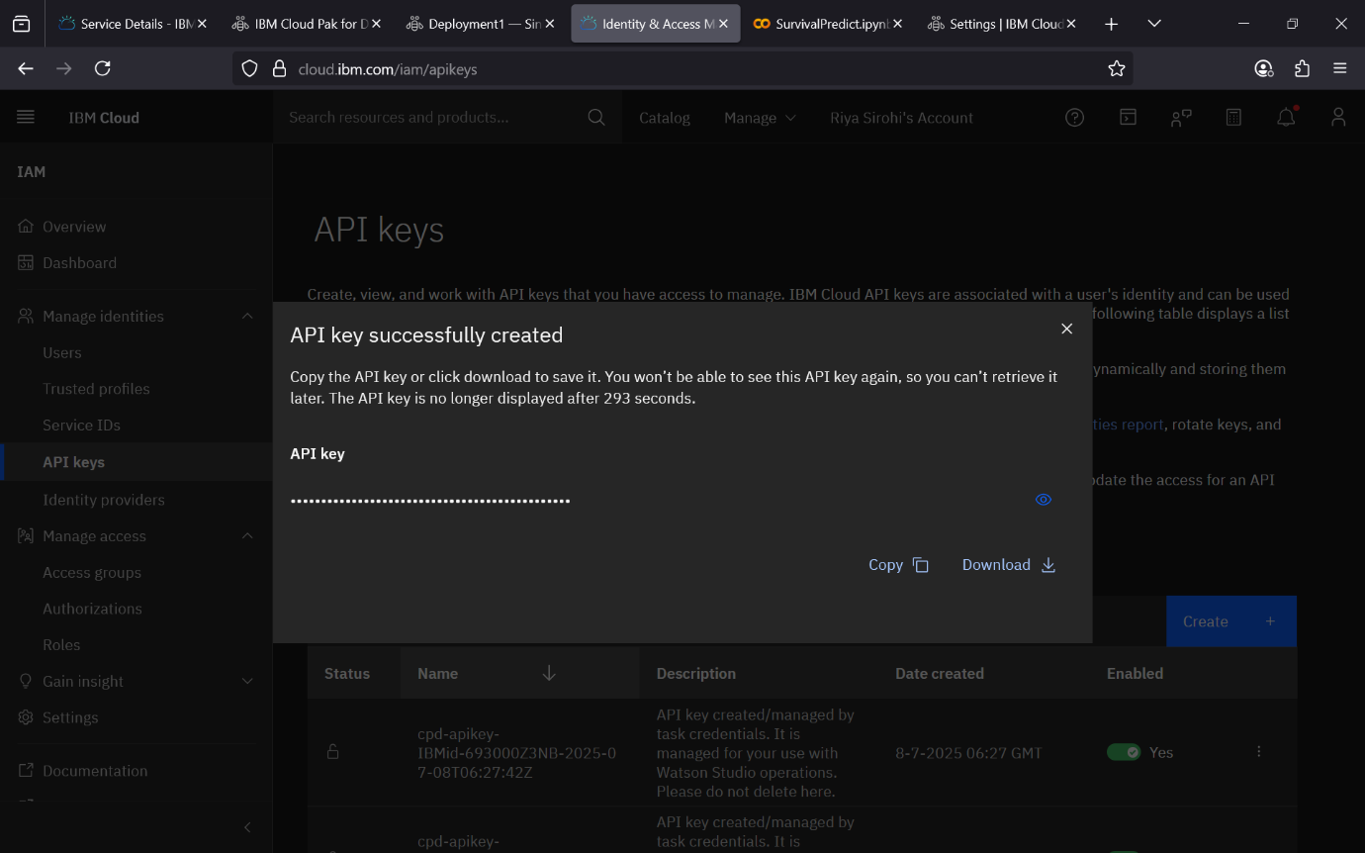

Step – 44 Now after creating just simply copy this API Key as this will be attached in the collab file in the API Key attribute. It helps in setting the connection between the colab and IBM Watson studio.

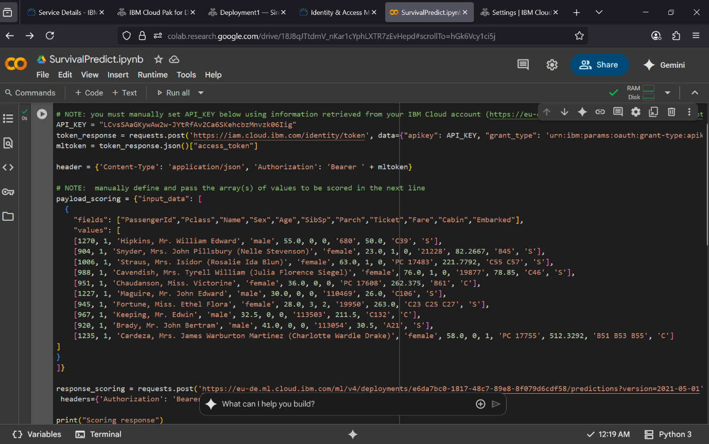

Step – 45 Finally update your fields and values by mentioning a list of all the column names of your dataset in the fields and random new test entries in the values. And finally press Shift + Enter to run this cell.

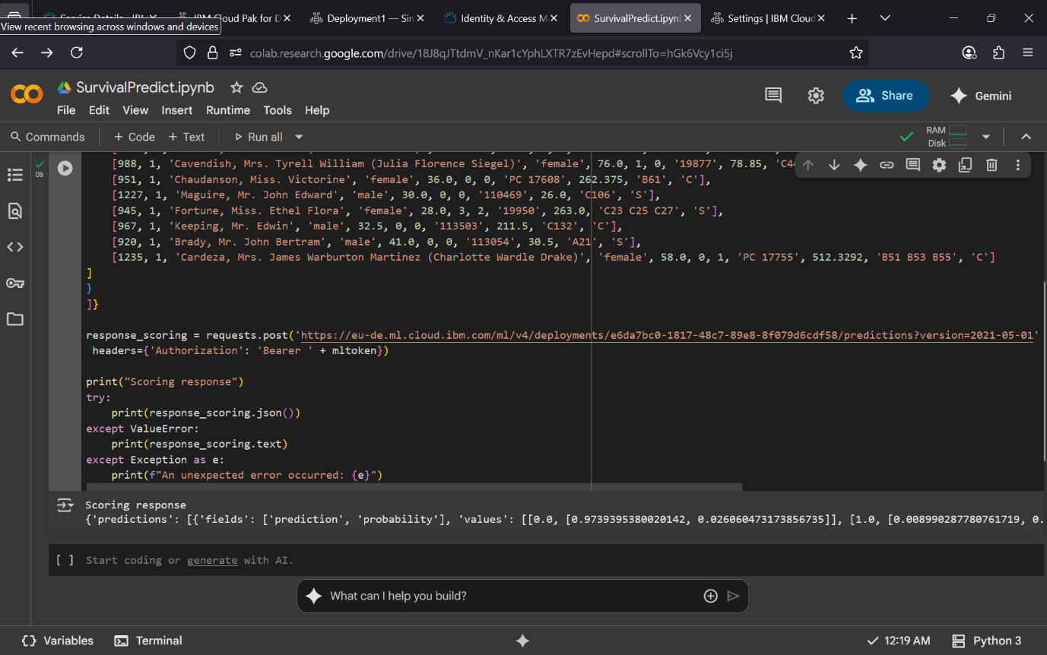

Step – 46 Finally you could see the output as Scoring response.